Teaching Care and Climate Justice Through on Campus Tours: Art With the ECC Five/Sixes
Compilation of Curriculums, Reflections, and Overall Framework and Conclusions
Louisa Hausslein

Curriculum for ECC touring SLC Gallery, Part 1: Gabriela Salazar, Observed
Introduction  5 mins | - Welcome kids to the gallery and tell them about Gabriella Salazar  - Have you ever been to a gallery or a museum? What are the rules?  - Have them share, confirm: Don’t touch now, we will touch later.  - How cool is it that we have a professional gallery that we can walk to from school?  - Prompt them with some guiding questions before walking around. Encourage them to think about senses.  - What does the art look like? What does it smell like?  - What do you think it would feel like? What do you think it would taste like? What sounds does it remind you of?
Tour  5 mins | - Encourage kids to walk around and look at all of the pieces. Some we have to look down to see, some we have to look up to see, and some we can even walk through or around.  - More guiding and reflecting questions:  - What does care mean? The artist thought a lot about care when she was making these pieces.  - Caring for the planet? Caring for plants?  - What colors do you notice?  - What do these pieces of art remind you of?  - The sculpture on the floor might have some objects that match up to prints on the paper artworks. Can you match any?  - Do you recognize any objects hiding in this art?  - Legos, trains, flowers, leaves…  - What is your favorite, and why?  - Do you notice that there are natural objects (leaves, grass, etc.) AND unnatural objects (toys, legos, blocks) together in the art pieces?
Activity  15 | Idea 1: I-Spy  - Provide a list of items for the kids to spot and have them go around and check them off.  - Legos, blocks, train tracks, leaves, grass, metal bowls, etc.  Idea 2: Leaf Rubbing  - Provide paper, crayons, and leaves for each student.  - Show that even professional artists use techniques that we learn at a young age.  - What texture do we see on the leaves? Does using this technique teach us more about leaves?  - Why do we think the artist chose to experiment with leaf rubbing?  Idea 3: Guessing game  - Hold up the smaller sample pieces of paper.  - Have a conversation with the kids: what shapes do we see? What colors/sizes of imprints?  - Give out hints!  - For example: If I held up the onion sample, I would say: this is a vegetable, it can be stinky, it can be round. When they guess onion, I can show the actual saved onion peels that Gabriella used. We can talk about natural dyes and why she might have made that choice.  Idea 4: Make your own!  - Have a table outside the gallery where kids can use the leftover materials to design their own piece of art, inspired by the floor piece.  - Individual or communal is ok  - Encourage them to feel and smell the objects and think about if it matched their earlier predictions in the gallery.  - As they place objects, we can talk about senses. We can talk about why Gabriella Salazar may have chosen to work with the objects that she did.
Conclusion  5 mins | - Wrap up activity by asking the kids about how they feel about what they made, and what they think they learned.  - Talk about why Gabriella Salazar made these pieces. Talk about her inspiration behind them.  - Salazar was inspired by windows, her childhood home, her kids, caring about the environment, and time.  - Talk about HOW Gabriella Salazar made these pieces.  - Share the examples of the real paper she used and have them touch it, and compare it to how it wore over time  - “Laying down prepared sheets of water-soluble paper over various things tied to her intimate world—leaves and branches, food scraps, her architect parents’ drawing stencils, rusty nails, screws, hinges and brackets, and her daughter’s building toys—Salazar then wets the paper until it returns to pulp. As the pulp redries, it becomes a cast of the field of matter, and absorbs the pigments of the plants and objects” - Care and Climate Website.  - Translation for kids: The artist took objects and laid them over paper, sprayed with water and vinegar, and watched what happened over time. Then she put all of the pieces together to make the big window-like shapes we looked at in the gallery.  - Does this remind you of the paper-making activity in class?  - Thank you for coming, we can’t wait to have you back for the next shows. There are two more artists coming this spring.

Reflection:
Gabriella Salazar's Observed exhibit was a perfect show to begin the chapter of integrating ECC students and the Heimbold gallery – the exhibit was playful, colorful, creative, and caring. It prompted relevant questions for the children like: How do we experience art? What does it mean to care for the environment? And, conveniently, ties in perfectly to the ECC kids current unit on making paper.
The 5/6 teacher, Cassandra, along with the students, explained that they have been taking bits of scrap paper, using water to make a pulp, and repurposing old paper to make new sheets. They plan on trying this with lots of materials: cardboard, colored paper, and different kinds of scraps. Therefore, the children were already familiar with some of the language used to explain Salazar's paper art. Later, they were inspired by Gabriella Salazar to think about natural dyes, shapes and imprints in homemade paper, and the value of art not looking new.
The ECC student’s delighted in trying to place certain objects, like shells, Legos, orange peels, leaves, and toy train tracks, from Salazar’s sculptural piece, For Our Work, in her various other hanging works. The students would notice a lego on the ground sculpture, for example, then run over to the wall and find the imprint.
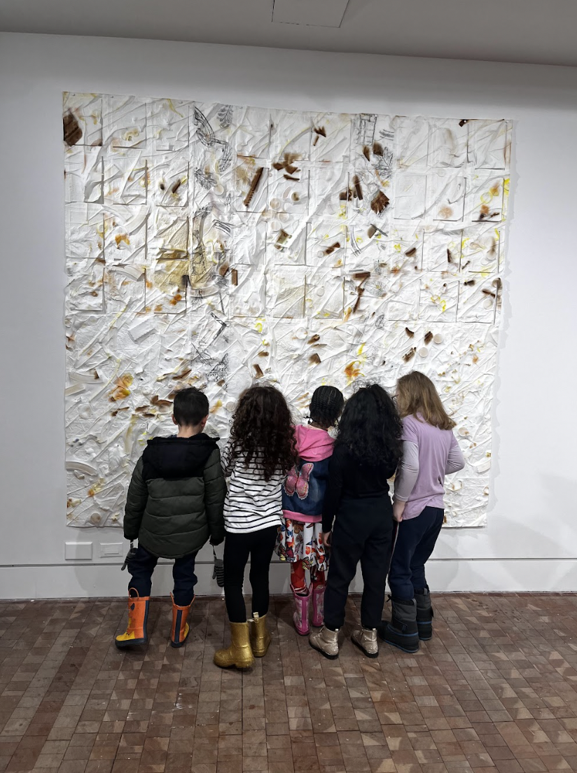
Kids admiring the art

After the welcome session and educational tour that I described in the curriculum above, we did two activities: Ideas 3 and 4. First, “Idea 4”: I encouraged the ECC student’s to stand around the two tables, with materials lined up, and make whatever they would like. The results were spectacular; some chose to work together and arrange smaller materials – dried rice, flowers, beans – into various abstract patterns. A few immediately used objects to make face shapes. Surprisingly, there was no clear favorite material. I thought some kids might battle over lego pieces, for example, but everyone seemed satisfied with what was presented.
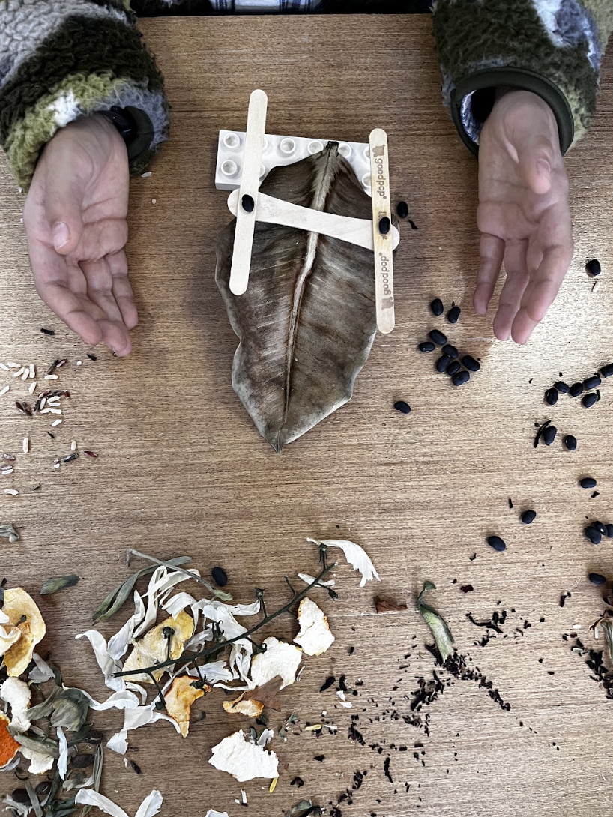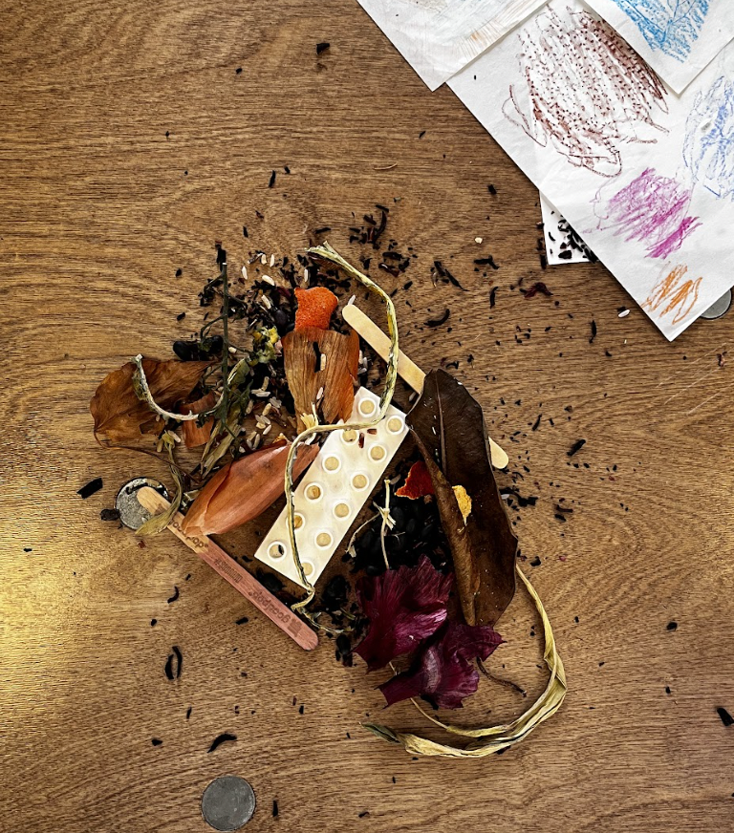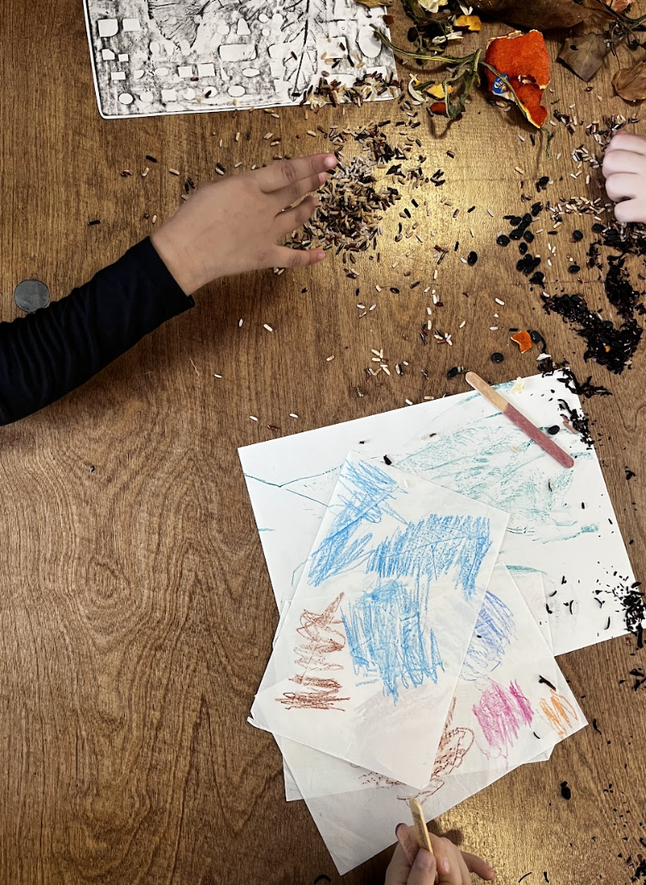
Kids Creations

I was inspired by the Reggio Emilia philosophy during this activity. Part of the Reggio educator philosophy is to consider that children have “hundreds of languages” and that “each material, including speech, music, poetry, painting, drawing, puppetry, etc. has the potential to become a language for children to use to construct and communicate their understanding of the world.” Activities like this one, which encourage children to use different materials to communicate, connect to both the Reggio philosophy and Salazar's works.
Patricia Tarr, author of “New Visions: Art for Early Childhood” encourages art educators – both inside and outside of a museum context – to ask this question: “How can we provide a relational context in which children and materials can enter into a dialogue that involves such listening with all of the senses?” She goes on to say that “to listen to materials is to become sensitive to their properties and possibilities.”
Talking about senses while inside the gallery was a big part of navigating Salazar's work with the children, especially because it was so tempting for them to touch. This activity allowed us to further talk about senses and provided a truly meaningful experience. As Tarr explains, being in touch with all of our senses through art helps us to have an “openness and sensitivity to listen and be listened to.” It helps us to be better listeners, more understanding, and more empathetic.

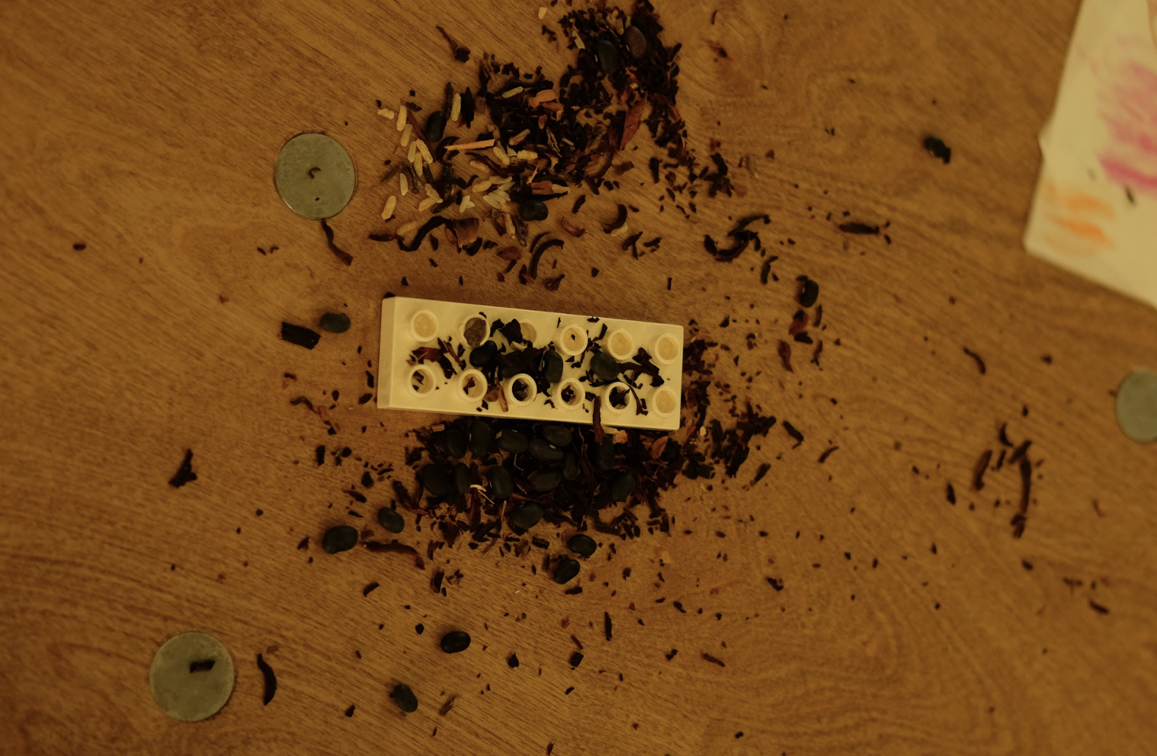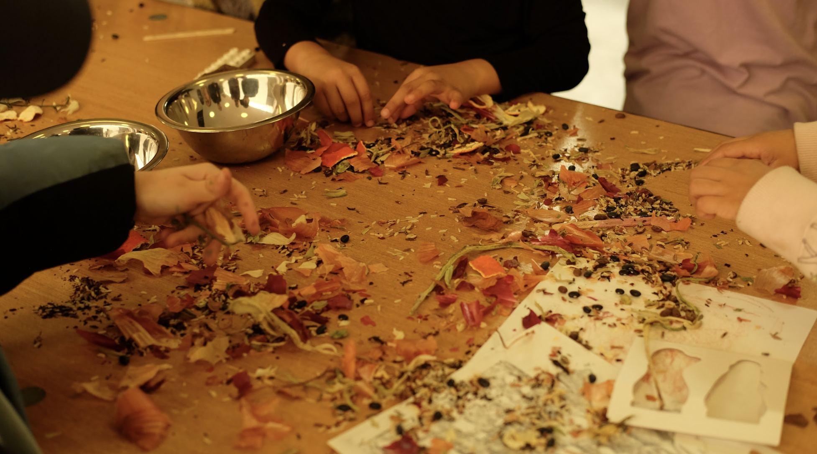
Kids Creations

In our last five minutes, I asked the ECC students to sit down on the floor in front of their work so we could reflect on it a little bit, then talk more about paper. I showed the examples of the plain paper that Salazar began with, and explained how it changed over time when water is added.
I feel lucky that we were able to follow the experience of viewing objects in a gallery/museum setting by actually touching the objects, and thinking about what they mean. As Marissa McClure explains in an Arts Education Policy Review, “children need organized, materials-rich environments that invite discovery, interaction, sensory and kinesthetic exploration, wonder, inquiry, and imagination” in combination with motivated and “responsive educators” in order to make teaching art a successful endeavor. Although the experience of viewing art was deeply valuable in itself, studies show that the hands-on element of art is what makes it really substantial.
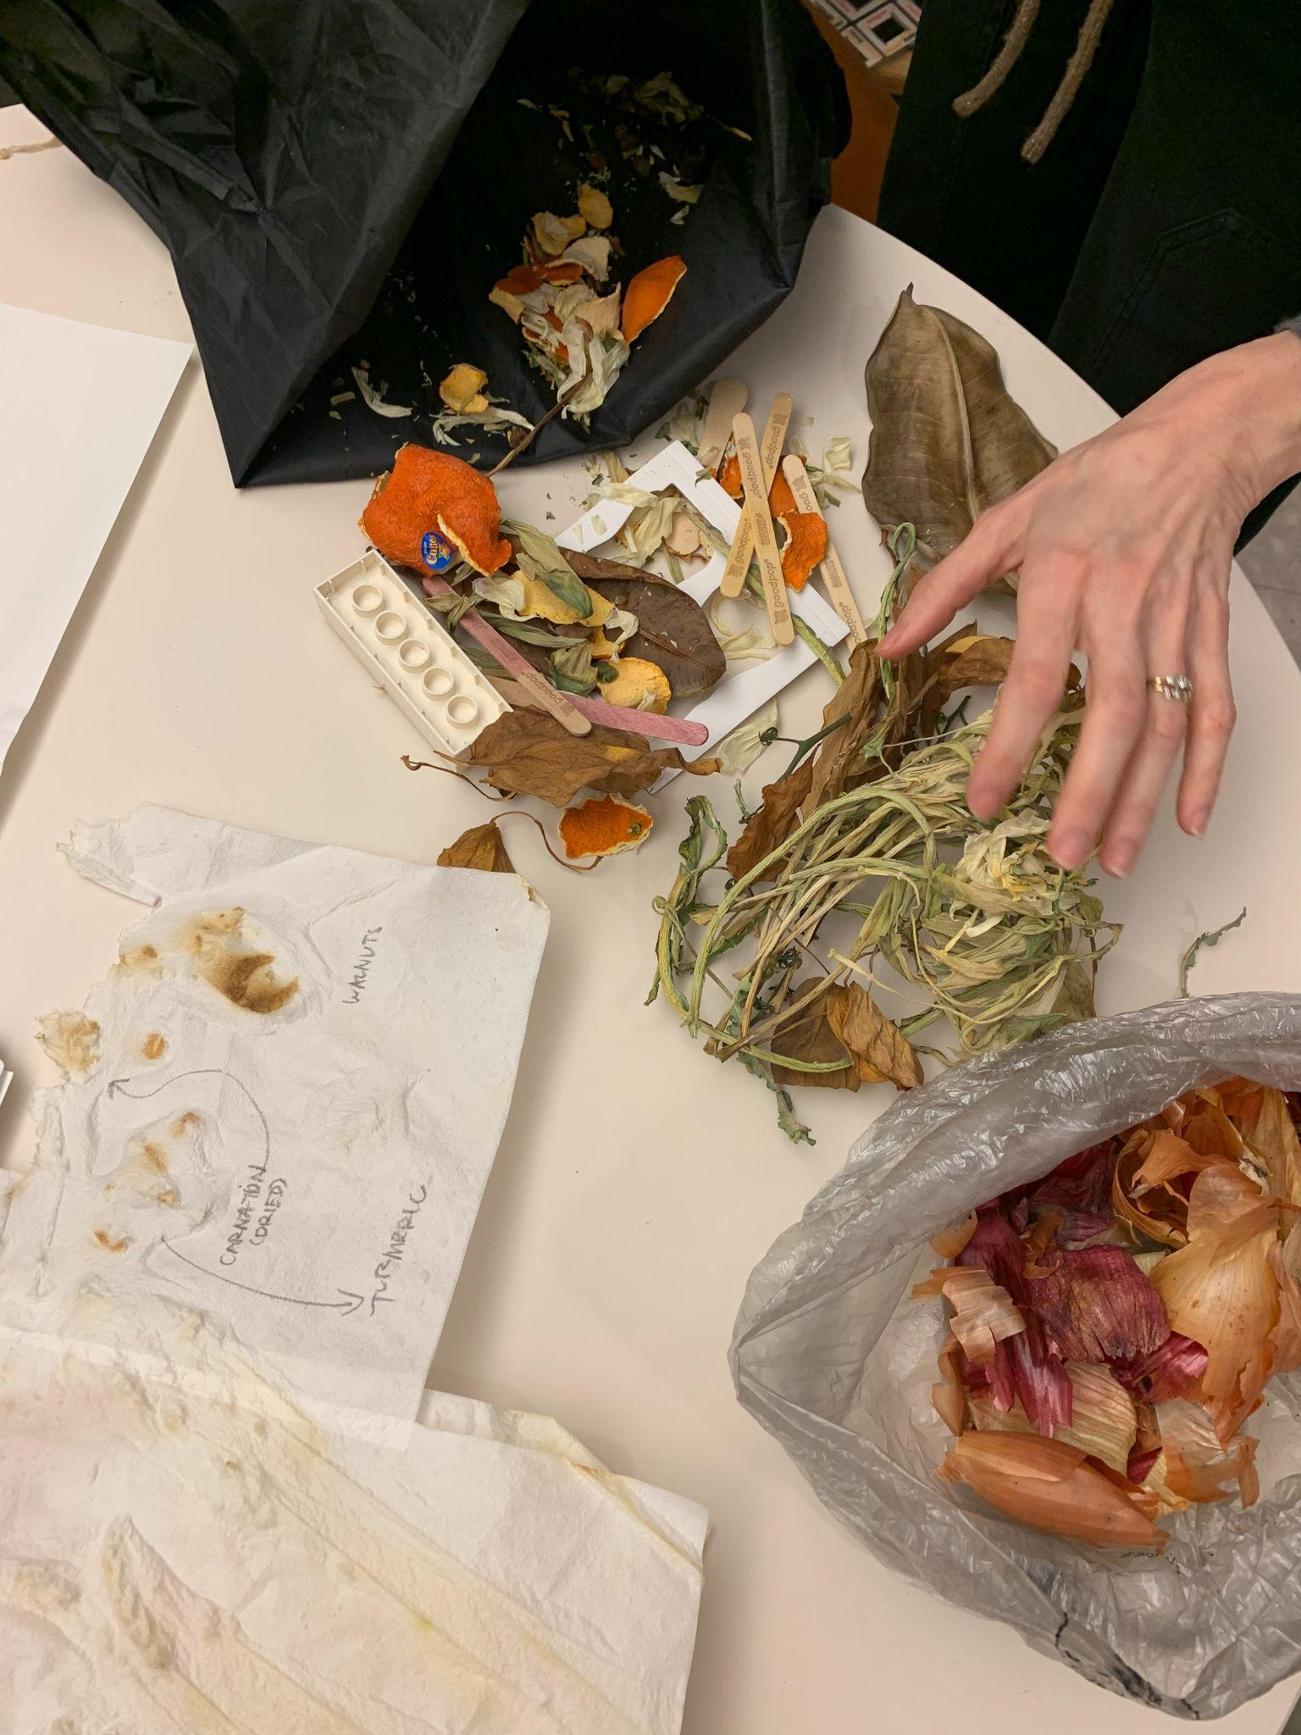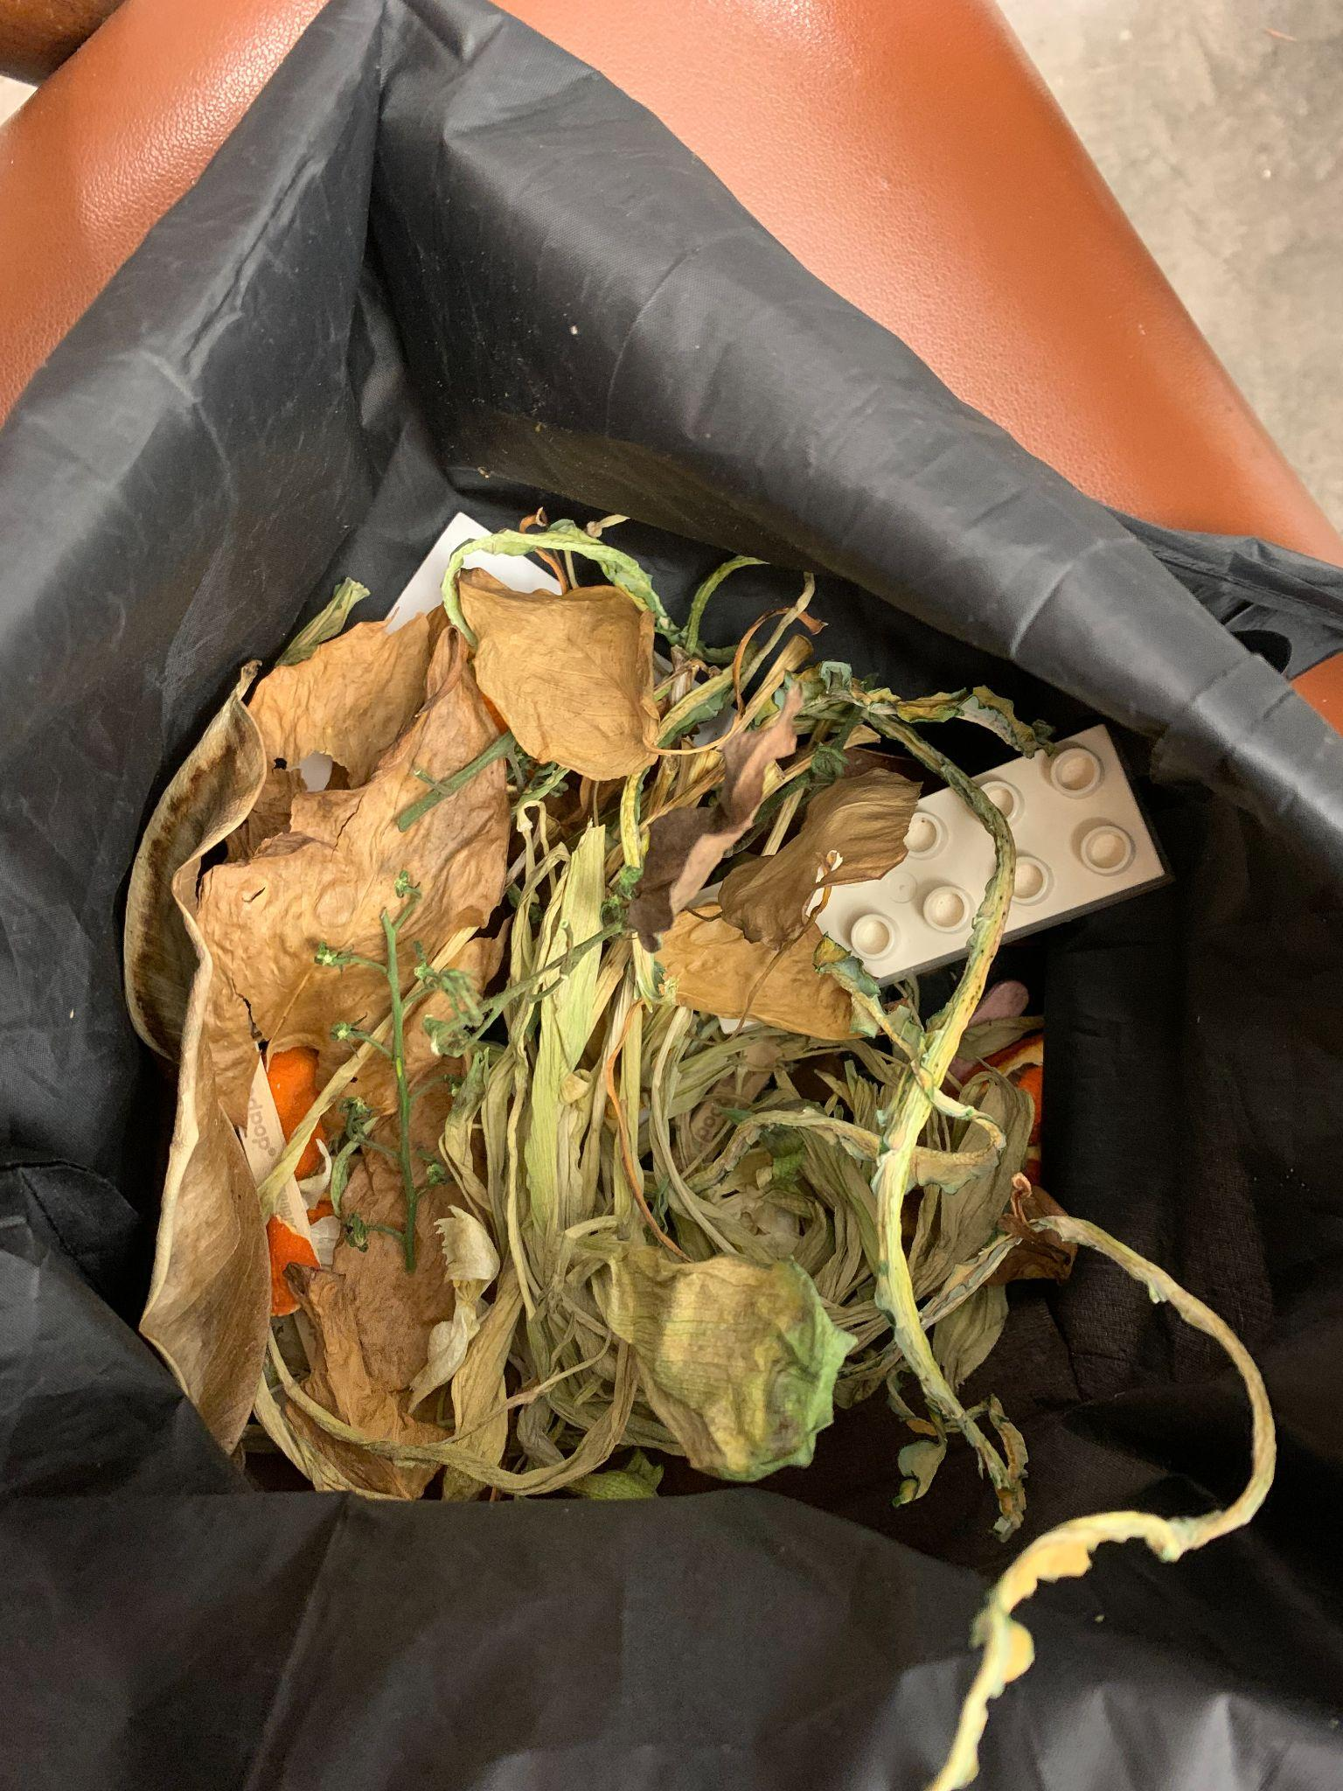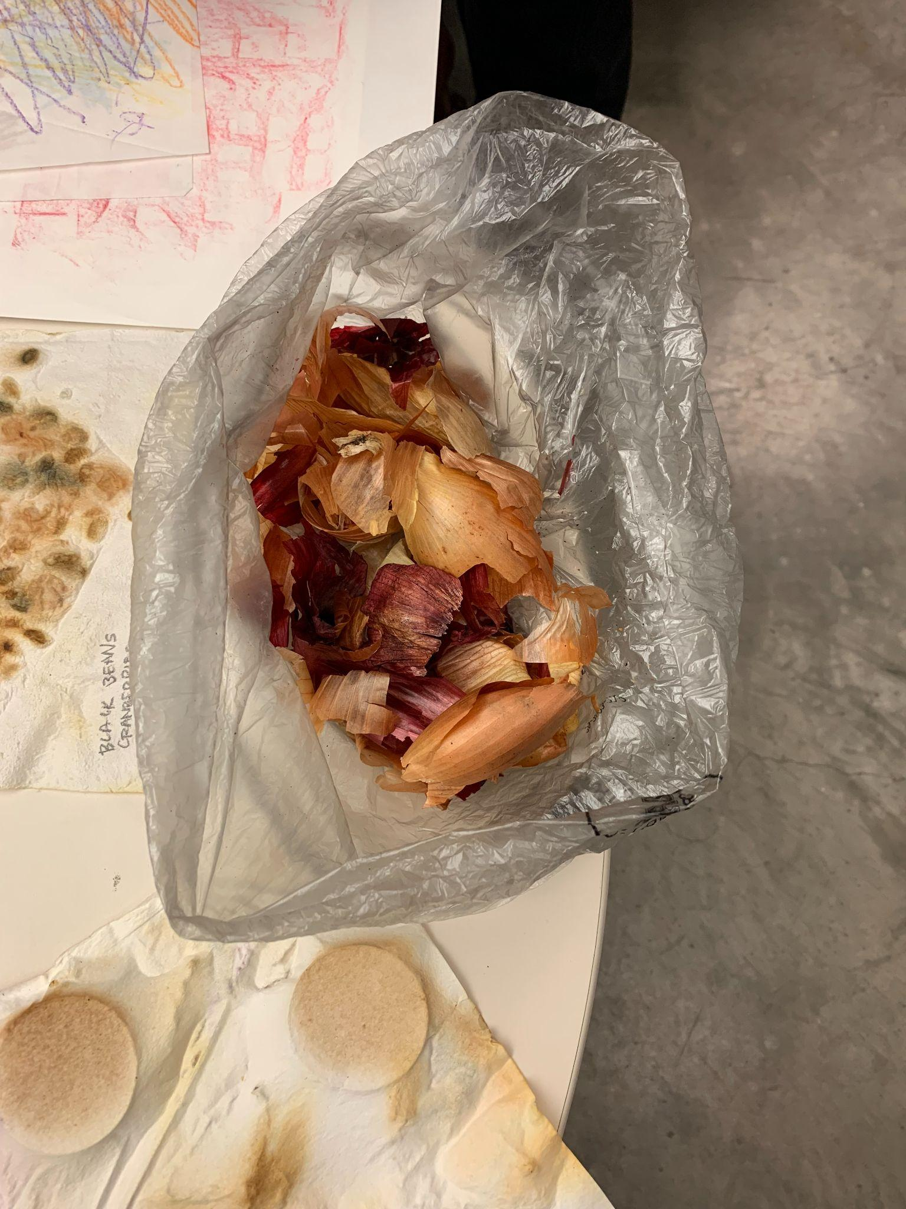
Raw Available Material

We ended this experience with one last activity, “Idea 3”: I held up samples of Salazar's work – paper with labels of experimented prints/dyes (onion, avocado peel, orange peel, beans, lavender, turmeric, walnuts, red cabbage, and vinegar) and gave a few hints until the kids guessed and revealed. The ECC student’s felt the pieces and continued to talk about smells and textures. They thought the idea of natural dyes were very interesting.
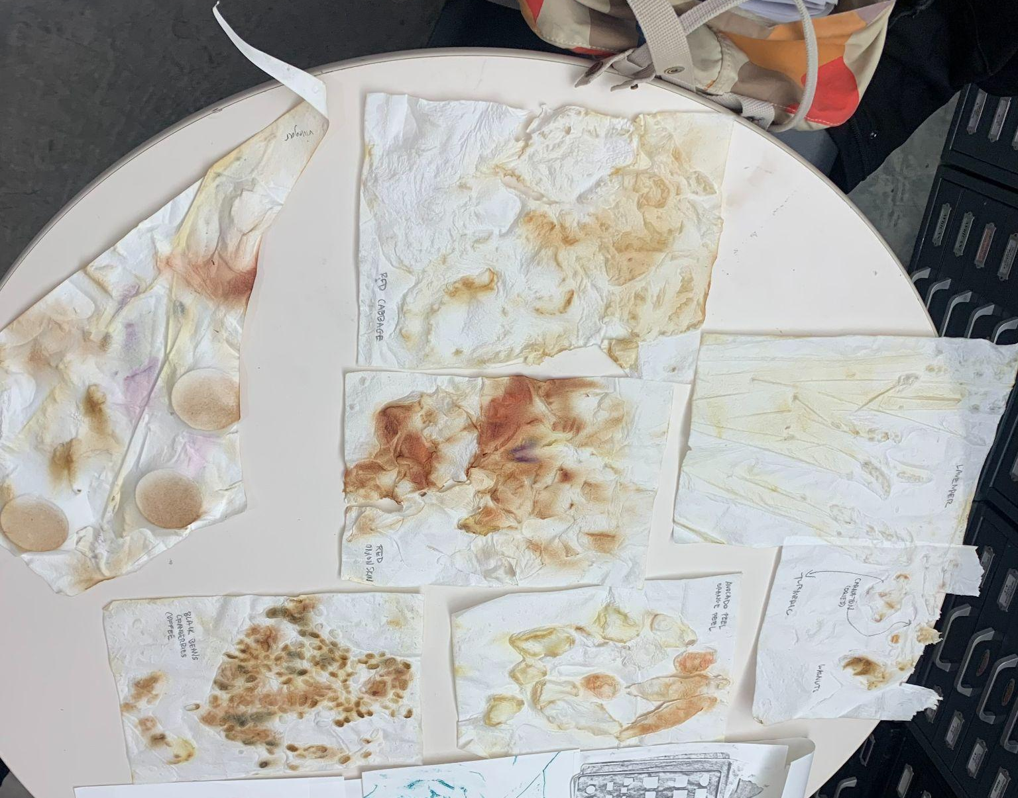
Labeled sample papers

It was a pleasure to be able to talk about art with the ECC students, and I could see how they could understand and appreciate it more as we talked about process. The progression from (1) guessing senses and observing, (2) to interacting with materials and discussing, then (3) learning more about her technical process seemed valuable to them. For me, it was a reminder how special it is when art can be fun and experienced.
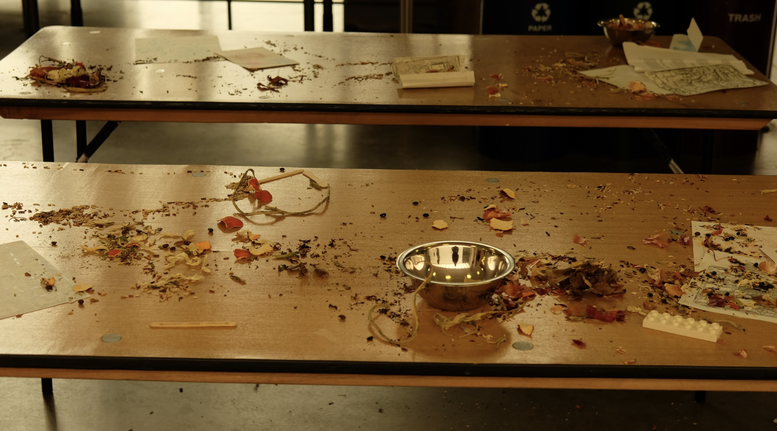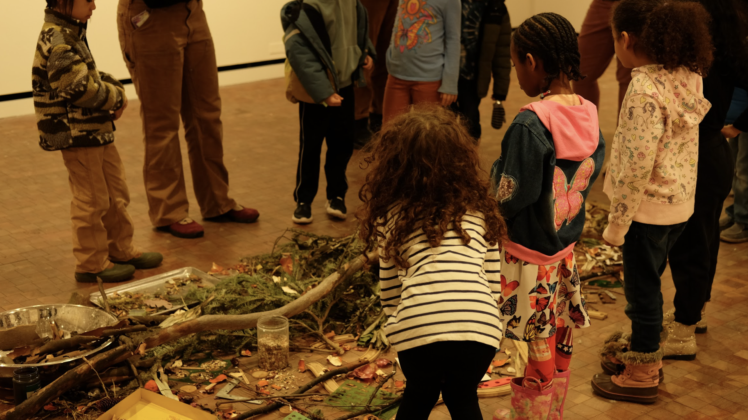

Curriculum for ECC Touring SLC Gallery, Part 2: Shanequa Benitez, But It's Ours
Introduction  5 mins | - Welcome kids to the gallery and tell them about Shanequa Benetez  - Shanequa is an artist from Yonkers!  - Ask if someone remembers the “museum rules” and if they can share again.  - Prompt them with some guiding questions before walking around. Remind them that it's helpful to think about senses.  - What does the art look like? What does it smell like?  - What do you think it would feel like? What do you think it would taste like? What sounds does it remind you of?  - How is this different from the last gallery tour we took?
Tour  5 mins | - Encourage kids to walk around and look at all of the pieces. Notice how some art paintings, some are collage, and outside of the gallery, there is photography.  - More guiding statements and reflecting questions:  - The artist thought a lot about caring for her community and her environment when making these pieces.  - What colors do you notice?  - What do these pieces of art remind you of?  - What is your favorite, and why?  - This artist wants to teach about what can happen to communities because of climate change. How can people teach through art?
Activity  15 mins | Prepare:  - 5 collage kits with a variety of materials  - Colored paper, magazine cutouts, ribbons, different textured collected items  - “Kit” is a used paper bag fashioned into an envelope.  - Glue sticks and scissors.  Pass out collage kits with the goal to think about imagining futures in a positive way  - Use photos of Yonkers as a “base” image  - Think of things you may like to incorporate into a dream city  - Take this chance to imagine what you may be inspired to change!  - Have fun being silly and creative to imagine something new.  - Don’t be afraid to dream big.
Conclusion  5 mins | Talk about collages. Talk about how art can be a way to imagine positive and creative futures, even when talking about things like climate change or struggling communities. Shanequa used art to teach people about problems that are happening or have already happened. We can use art to teach people too – but also have fun and imagine new things.

Reflection
Although I wasn’t able to actually give the ECC students a tour of Shanequa Benetiz’s contribution to the Care and Climate Justice series, it's valuable to think through how it would have gone. Benitez’s exhibit, titled But It's Ours, explores environmental racism and redlining, specifically in her hometown, Yonkers. Although touching on heavy topics, I think the students would have enjoyed this exhibit thoroughly – it was colorful, multimedia, and featured some recognizable images. Bentitez thought about what it means to care for communities and environments in this exhibit, and what it means to teach people through art. These would have been important talking points with the kids.
Additionally, my background research into museum education has proven that art and museums are one of the best ways to teach topics related to multicultural education. In Joseph Suinas journal article “Museum Multicultural Education for Young Learners” he explains that “Museum educators are in an excellent position to develop ideas and attitudes critical to the success of young learners in understanding and ultimately participating in our multicultural world.” Small galleries are no exception.
Benitizes connection to the city of Yonkers, which Sarah Lawrence College and the Early Childhood Center are located in, would have also provided meaningful discussions having to do with locality and place. I think the ECC students would have really enjoyed celebrating a Yonkers artist – someone from here, who loves it here, despite its structural and historical flaws.
In Allison Wickens “Museums and Community” journal article, she explains that “In early childhood, when kids are finding new opportunities to express and understand themselves, repeat visits to a local museum can provide a familiar environment to explore and make sense of the world.” The combination of visiting a gallery within walking distance from the ECC (which they can return to) with art that has to do with the very location we are in, relates to these important ideas of becoming familiar with and learning about an environment.
Two years ago, in a multimedia class with local middle school aged students, I led a collage-making workshop which celebrated discussions of Yonkers by thinking about positive and creative futures. If I had been able to give the kids from the ECC a tour of But It's Ours, I would have followed with a similar activity.
In the workshop, we provided students with background photos of Yonkers and encouraged them to work together and collage over these photos in order to create a “dream city.” They used various colored paper, photos, leaves, and ribbons to be imaginative, silly, and creative. During the activity, we were able to have open and honest conversations about what it means to advocate for a place you care about. The kids shared both big and simple dreams through their words and their art. I have attached photos below.

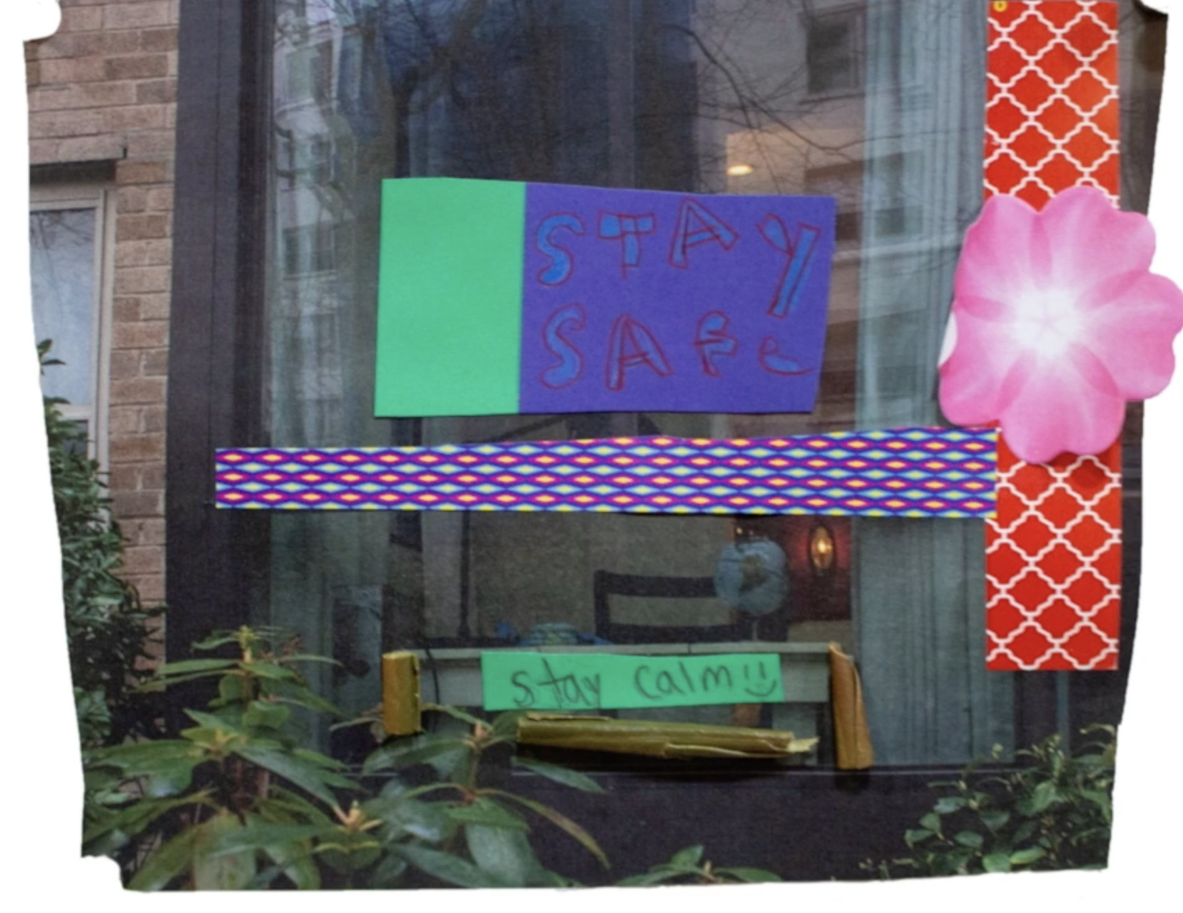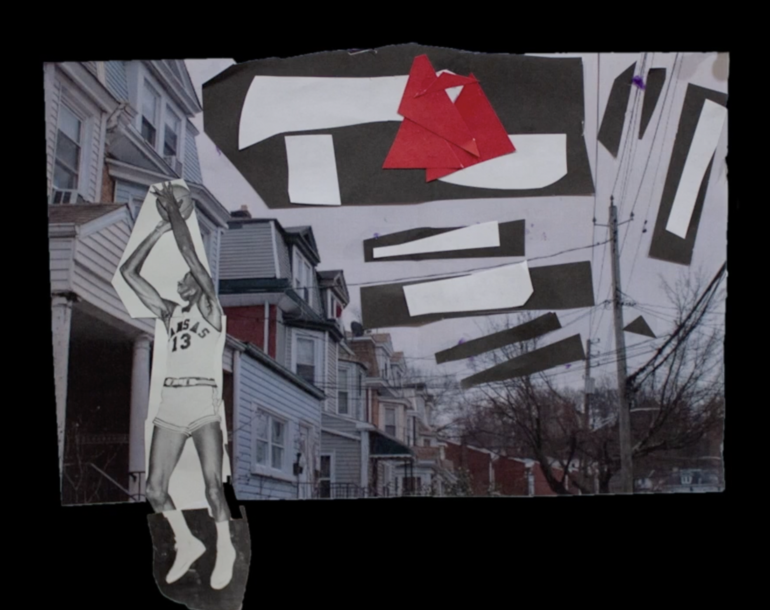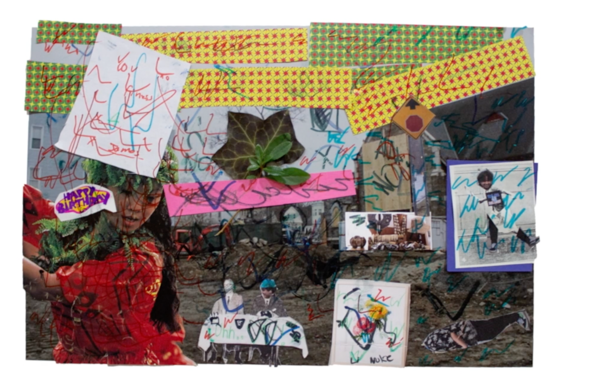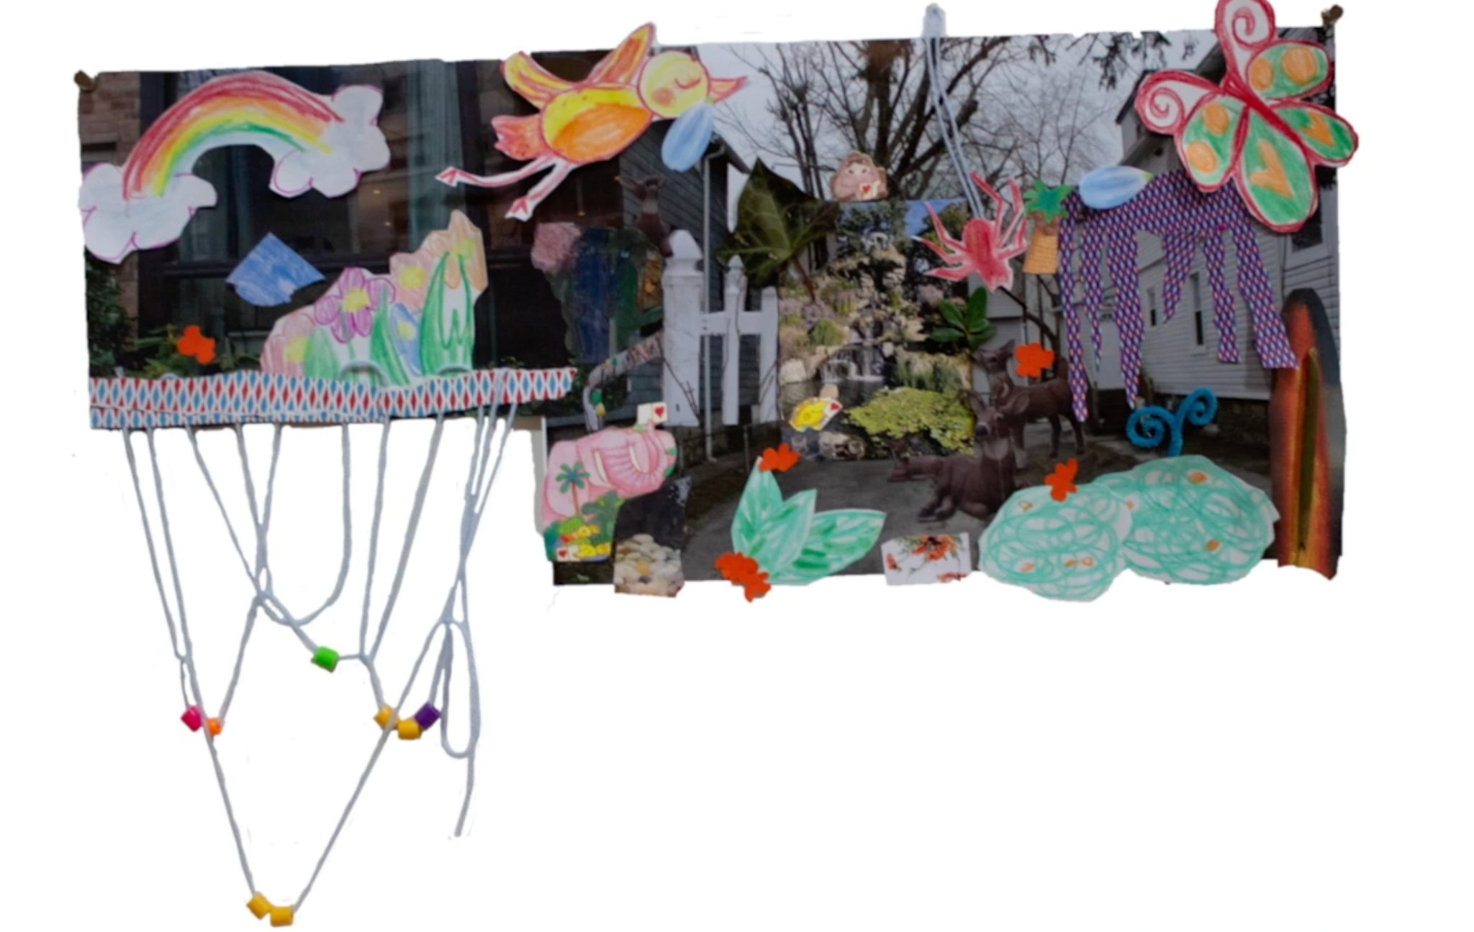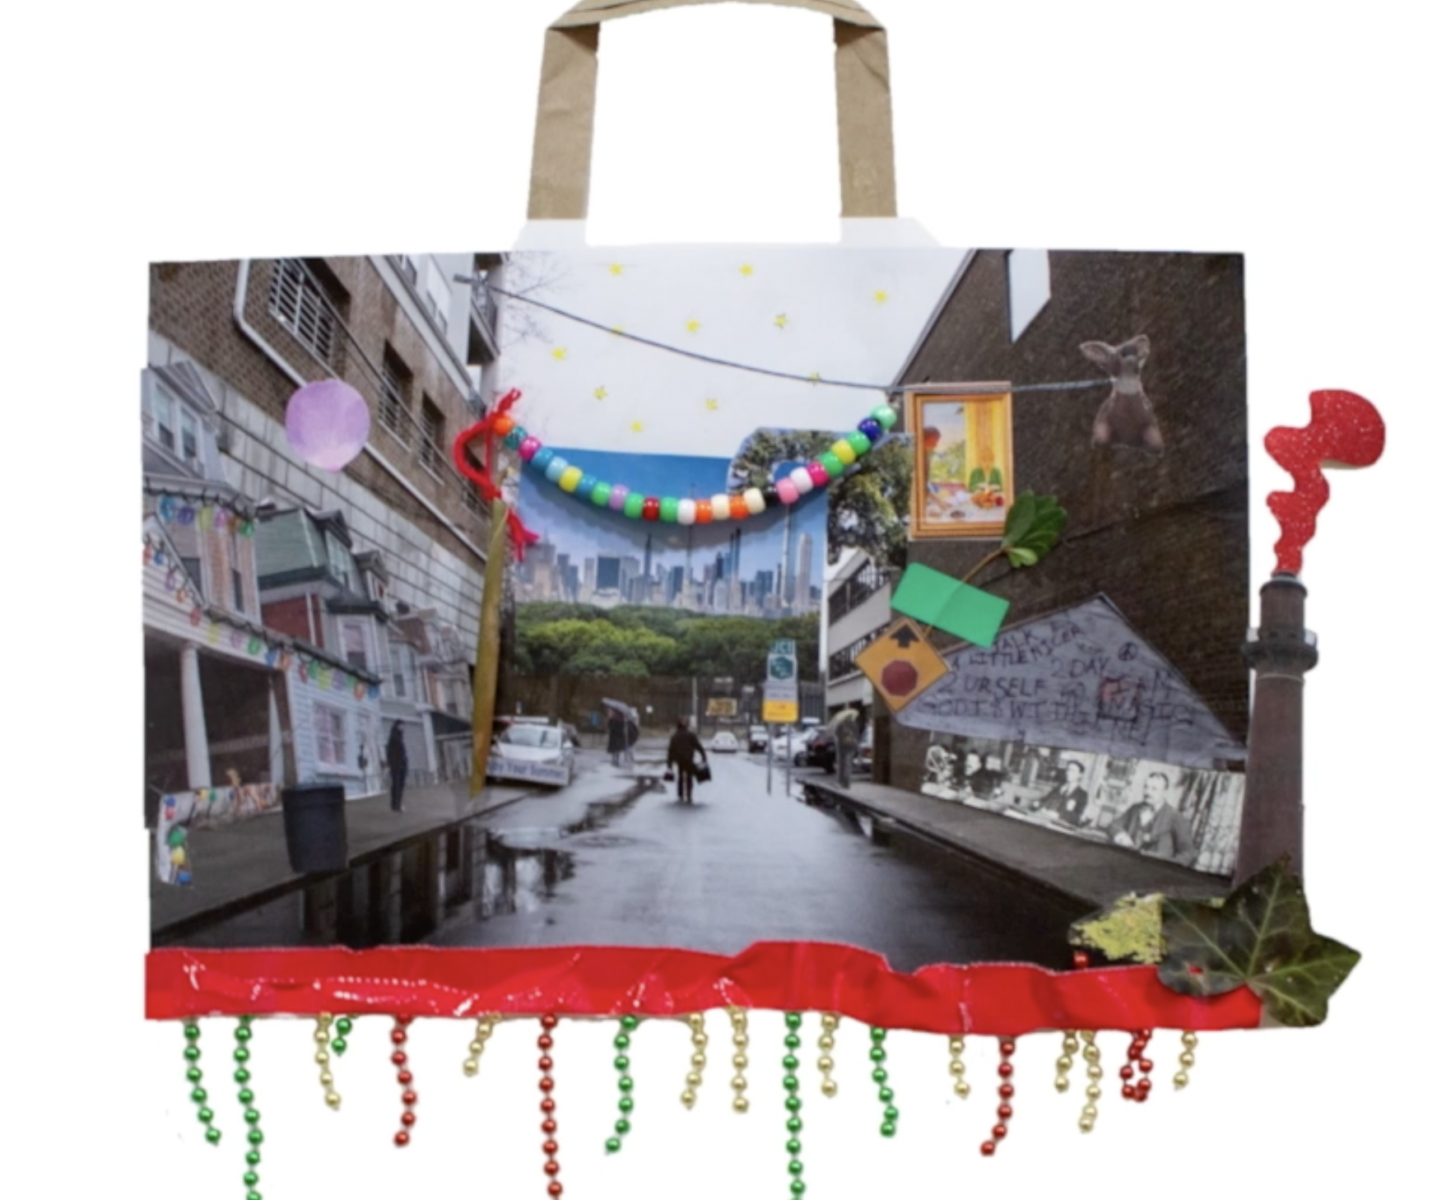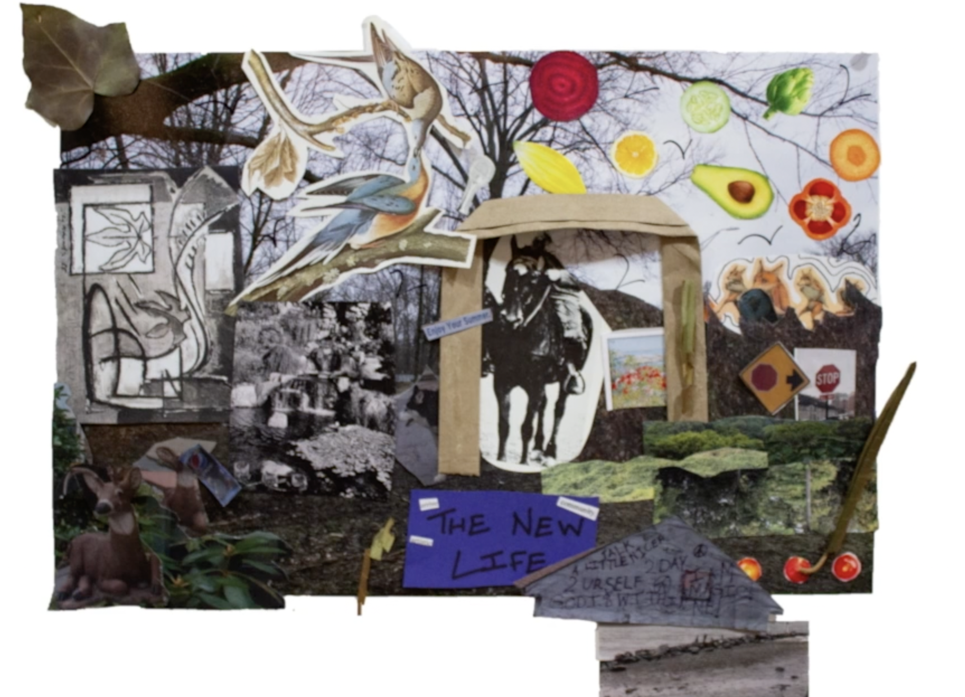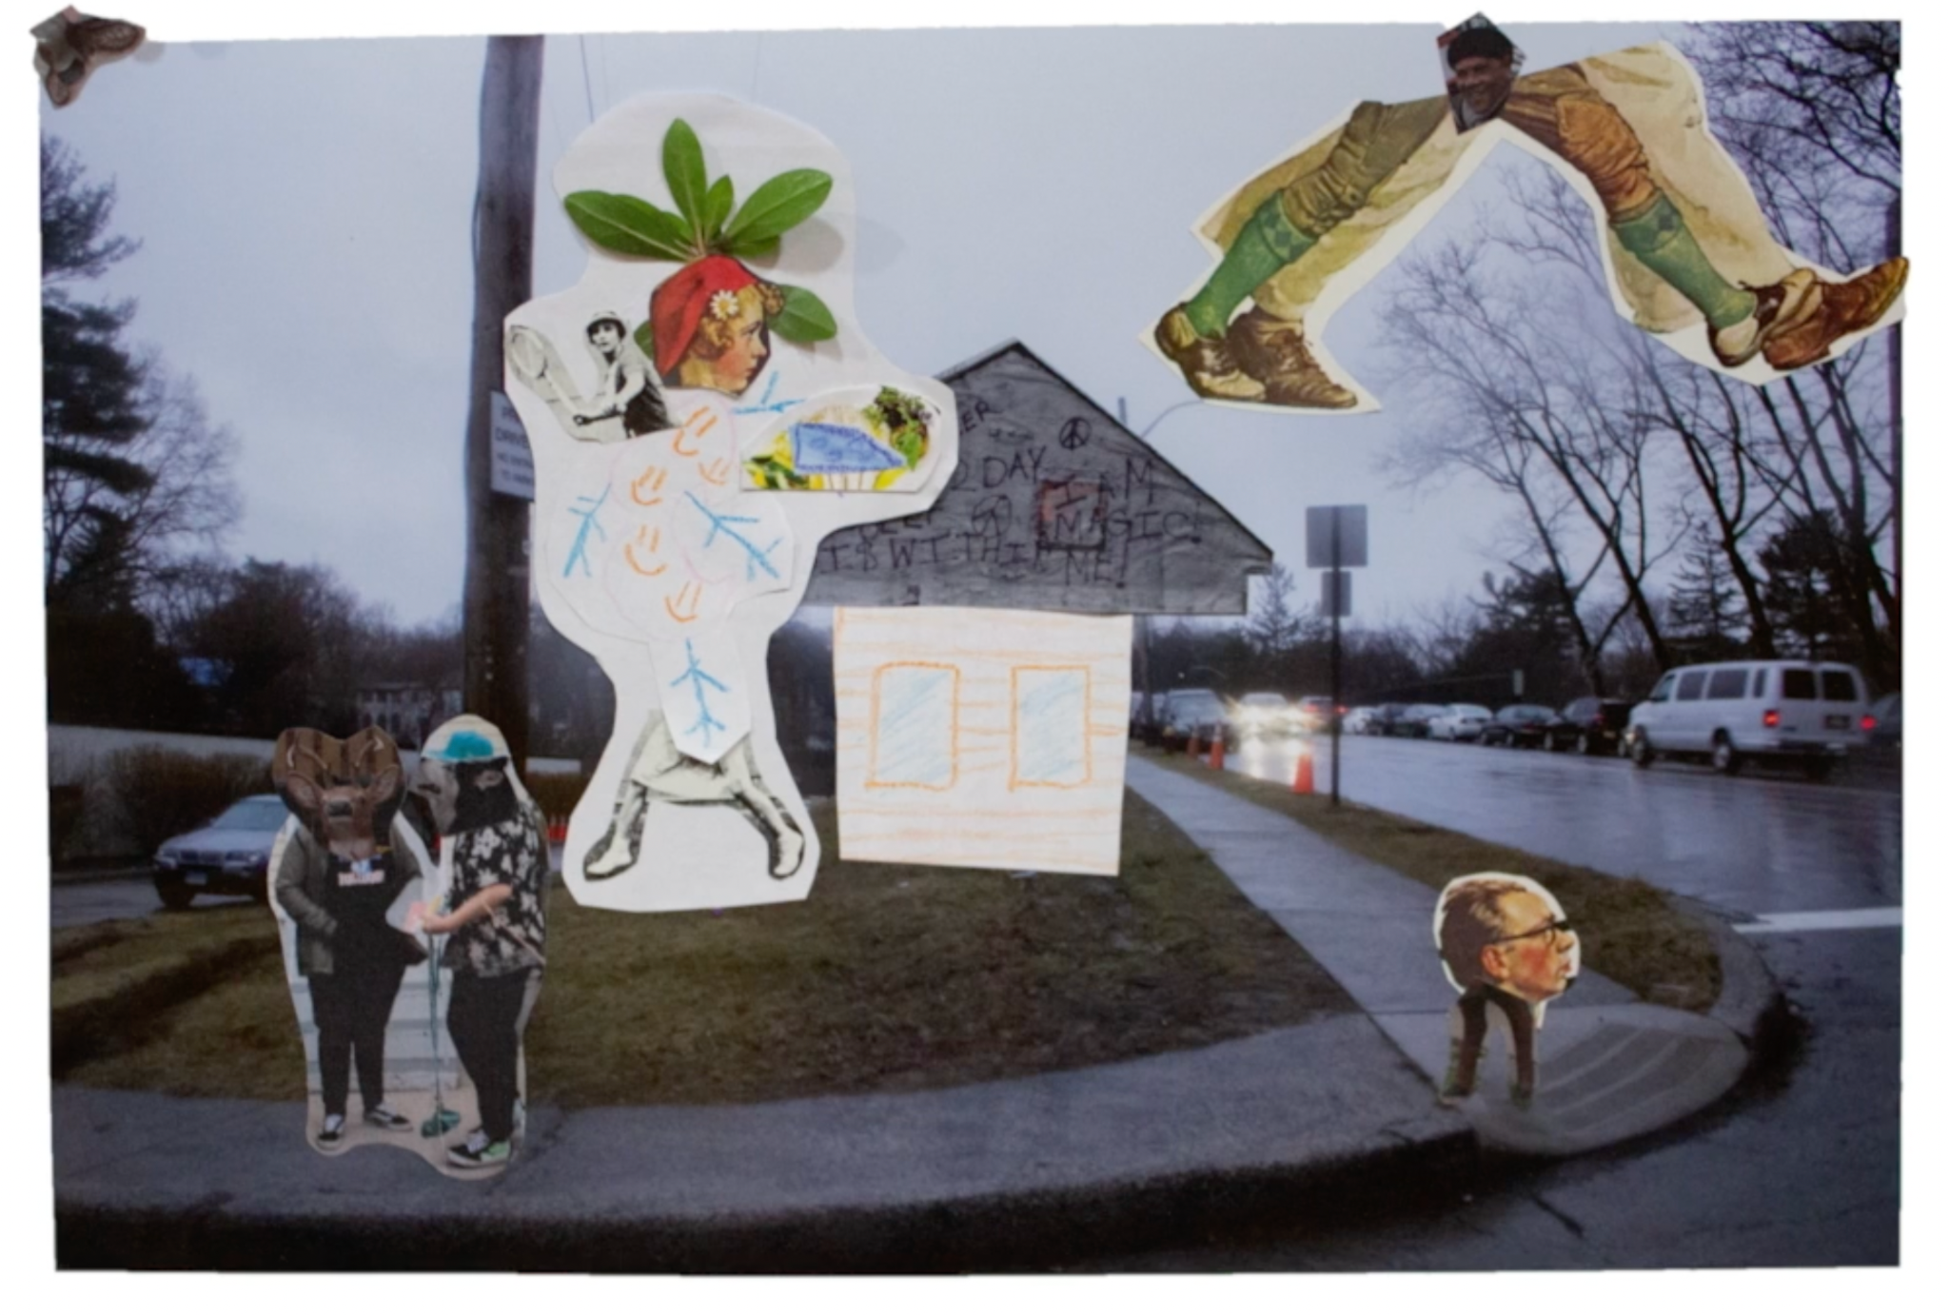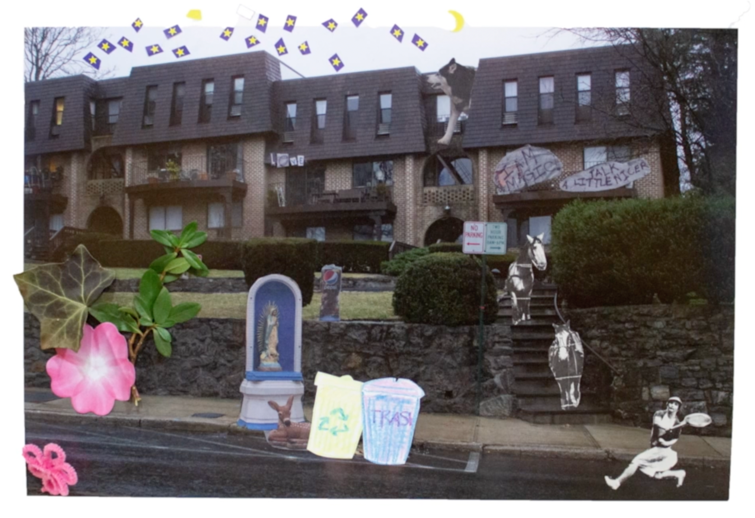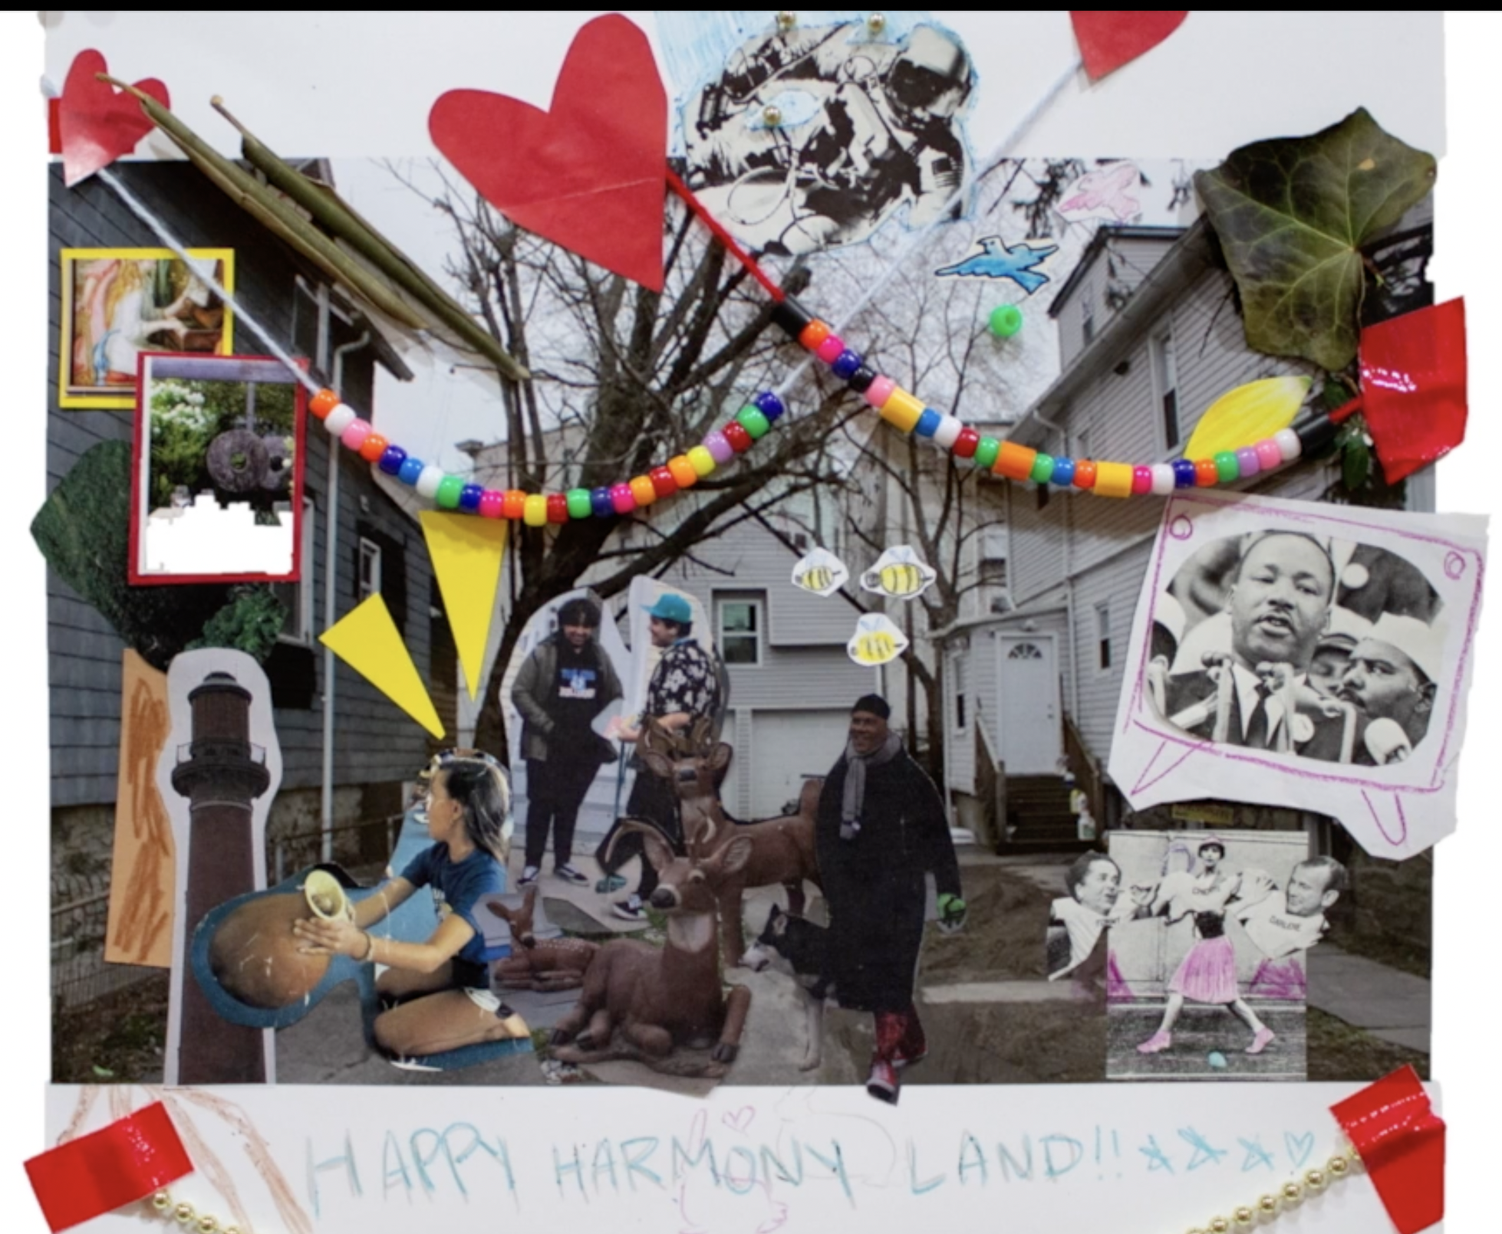

Curriculum for ECC Touring SLC Gallery, Part 3: Groundings
Introduction  5 Mins | - Welcome kids to the gallery  - Ask if someone remembers the “museum rules” and if they can share again.  - Confirm: Talking is ok, touching is not. We will have hands-on activity after the tour.  - Today is going to be a little different than the last tour of the gallery, because there are so many artists in the room. Let's walk around the room together, and I will tell you a little something about each one of the artists. Then you can walk around and observe whatever you like, before we go into the lobby for a sewing activity.  - Prompt them with some guiding questions before walking around.  - There are a lot of different artists and different kinds of art in this exhibit.  - Can anyone share what different kinds you notice?  - Confirm: sculpture, video, textile (fabrics), and photography.  - Remind them that thinking about senses is helpful when looking at art.  - What does the art look like? What does it smell like?  - What do you think it would feel like? What do you think it would taste like? What sounds does it remind you of?
Tour  10 mins | More guiding questions:  - What do you think about all of these different kinds of art together in one room?  - There are a lot of colors in this exhibit, what do you notice about them?  Cannupa Hanska Luger / Transmission Fluid 2042 /Native American Video  - What are they wearing?  - Provide context: Outfits are handmade with collected material, based on traditional clothes from their ancestors.  - Have you ever seen traditional Native American outfits like these ones?  Cannupa Hanska Luger / Art - I - Fact/ Tools+Weapons  - What do these weapons and tools look like? Can anyone name them?  - Do you think these could be used?  - Is anything surprising about these?  - What colors do you notice?  - Why do you think they are hanging on the wall?  - Provide context: they are made out of ceramic (clay) and painted, they are not meant to hurt anyone.  Emily Johnson / Being Future Being / Quilts  - Talk about the community aspect: Many people of all ages helped the artists to write things on squares, and even sew things together.  - The artist taught many people how to sew for this project.  - Talk about the worn pieces:  - What would it be like to wear one of these outfits?  - Heavy/light? Warm/cold?  - What would it be like to dance in one of these outfits?  Courtney Desiree Morris / Solistolgia Series / Photos  - Provide context: This style of art is called photography  - The artist designed outfits and arranged a set to take these photos.  - What do you notice about this image?  - Notice the table in the middle of the road?  - Why do you think this woman is dressed up fancy next to an empty pool?  - Why do you think she is wearing a mask?  - Is there something unusual about it?  Sarah Roselena / Above Below / Mars Tapestries  - Provide context: The artist programmed this design into a computer, then turned it into a tapestry.  - What is a tapestry? Blanket? Rug?  - Crafting textiles is a historical, traditional method of art. Using a computer to program art is a new, futuristic method. Notice how she combined both.  - Notice how we can walk around it, and see different things on each side.  - She was inspired by mars and maps when making these.  - Think about what earth would look like from above, think about what mars would look like.
Activity  10 mins | Prep:  - Prepare pieces of cardboard with pencil outlines of simple drawings and poke evenly spaced holes throughout the line (reference picture below).  - Have the pieces connect at the end, puzzle-like, to connect to Emily Johnson's idea of community  - Note: If you have more time, kids can draw and/or poke the outlines themselves, ahead of time.  - 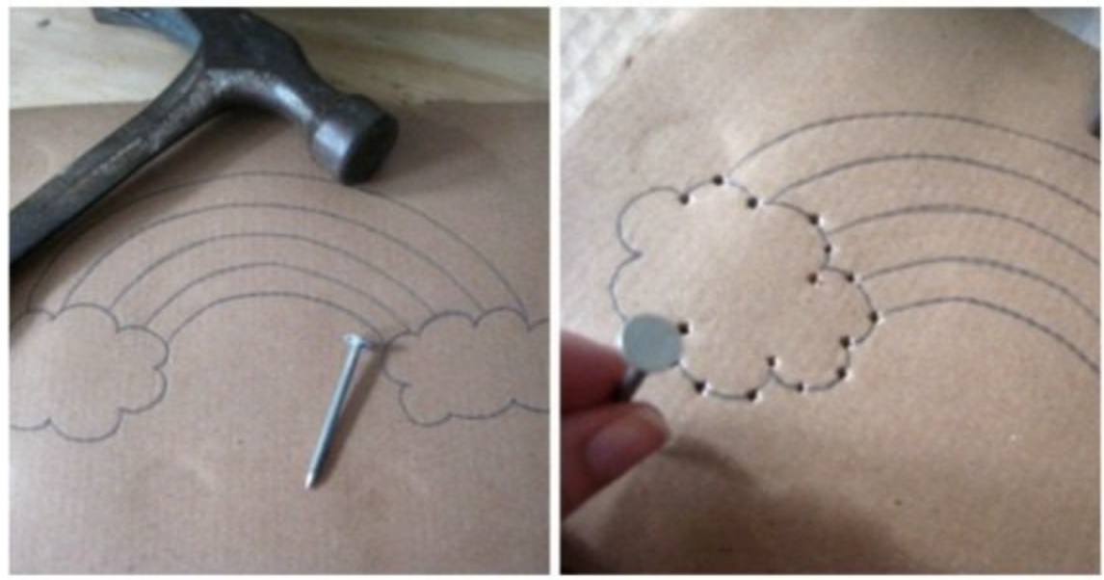  - Old cereal boxes are a good texture of cardboard to use here.  Activity:  - Demonstrate to the kids how to thread a needle and use the holes on the cardboard to sew up and down and make a pattern.  - Use kid-friendly, large plastic needles and various colored string.  Reflect:  - When the artist Emily Johnson sewed together the quilts we looked at in the gallery, she taught a lot of people how to sew and asked for their help.  - Part of her work as an artist is to teach, learn, and collaborate.  - Do you think it would be fun to do a big sewing project with more people?  - Sewing can be used for repairing or making clothes or blankets, or as art like we did today.  - Explain how people sew fabric together to create/repair, if they are curious.
Conclusion  5 mins | Ask:  - What did you think about the sewing activity? Do you think you would like to try it again?  - Does anyone have any last thoughts or questions on any of the art we saw today?  - Do you think it was cool to see so many different kinds of art alongside each other?  - If you can remember, can you tell how this exhibit is different from the last one we toured?  Thank everyone for coming, encourage them to keep their sewing projects and think about how they can continue to teach people how to sew, for example.

Reflection
Experiencing Groundings with the ECC students showed an engagement with the children on a whole other level. They were enthralled in the varieties of artworks, which prompted questions like: What is community art? How can art be a way to show you care for the environment?
As it's shown laid out in the curriculum, the dynamic of talking about a variety of artists and their art styles worked very well. Works from Emily Johnson, Cannupa Hanska Luger, Courtney Desiree Morris, and Sarah Rosalena are featured in this exhibit. Unsurprisingly, the kids were most drawn to Cannupa Hanska Luger’s Transmission Fluid 2042 videos, as well as his Art - I - Fact tools and weapons, and Emily Johnson’s Being Future Being quilts.
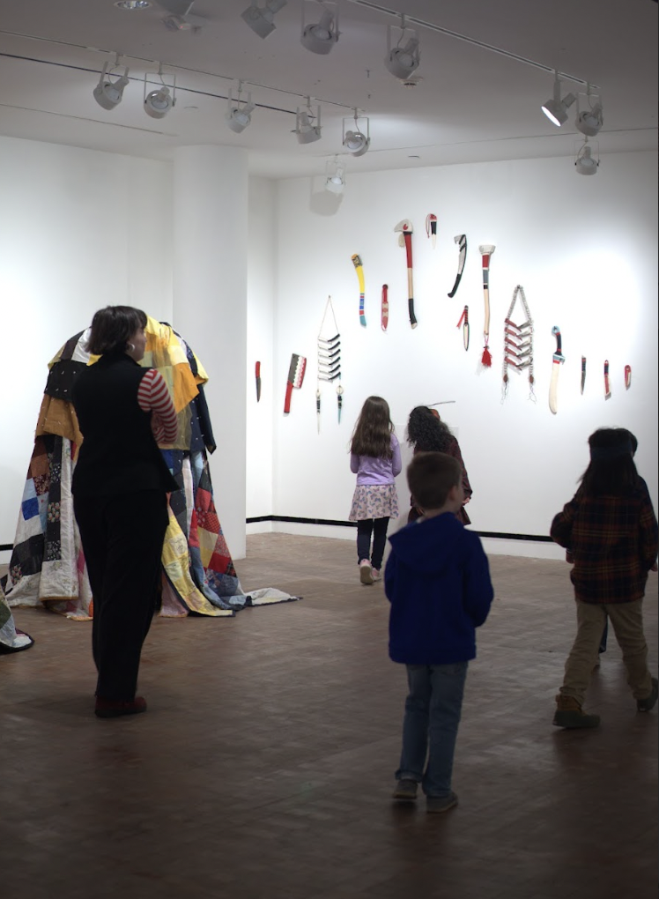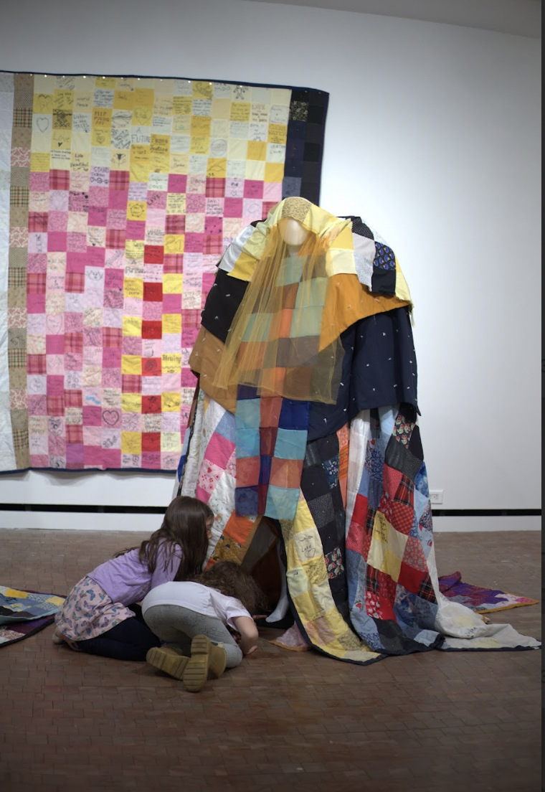
Art - I - Fact, Cannupa Hanska Luger Being Future Being, Emily Johnson

One ECC student repeatedly spoke about the cliffs shown in one of the videos – the vast landscapes inspired him and made him feel curious, prompting lots of land related questions. Another student enjoyed pointing out recognizable squares within Johnson’s worn pieces – “I see Hello Kitty!” After I explained that Luger’s tools and weapons were made out of ceramic, another kid was amazed, he said: “That looks really good, like a real sword.”
One of my favorite moments was when I explained to the children that both sides of Sarah Roselena’s Above Below Mars inspired tapestries could be viewed. They ran to the other side and exclaimed things like “Woah!” “That's crazy!” and “I didn’t expect that!” I certainly didn’t expect that reaction.
The variety of mediums and artists present in Groundings held the kids' attention spans and kept them interested for a long time. It was really sweet watching them run back and forth between pieces, and have them ask and talk about the different mediums.
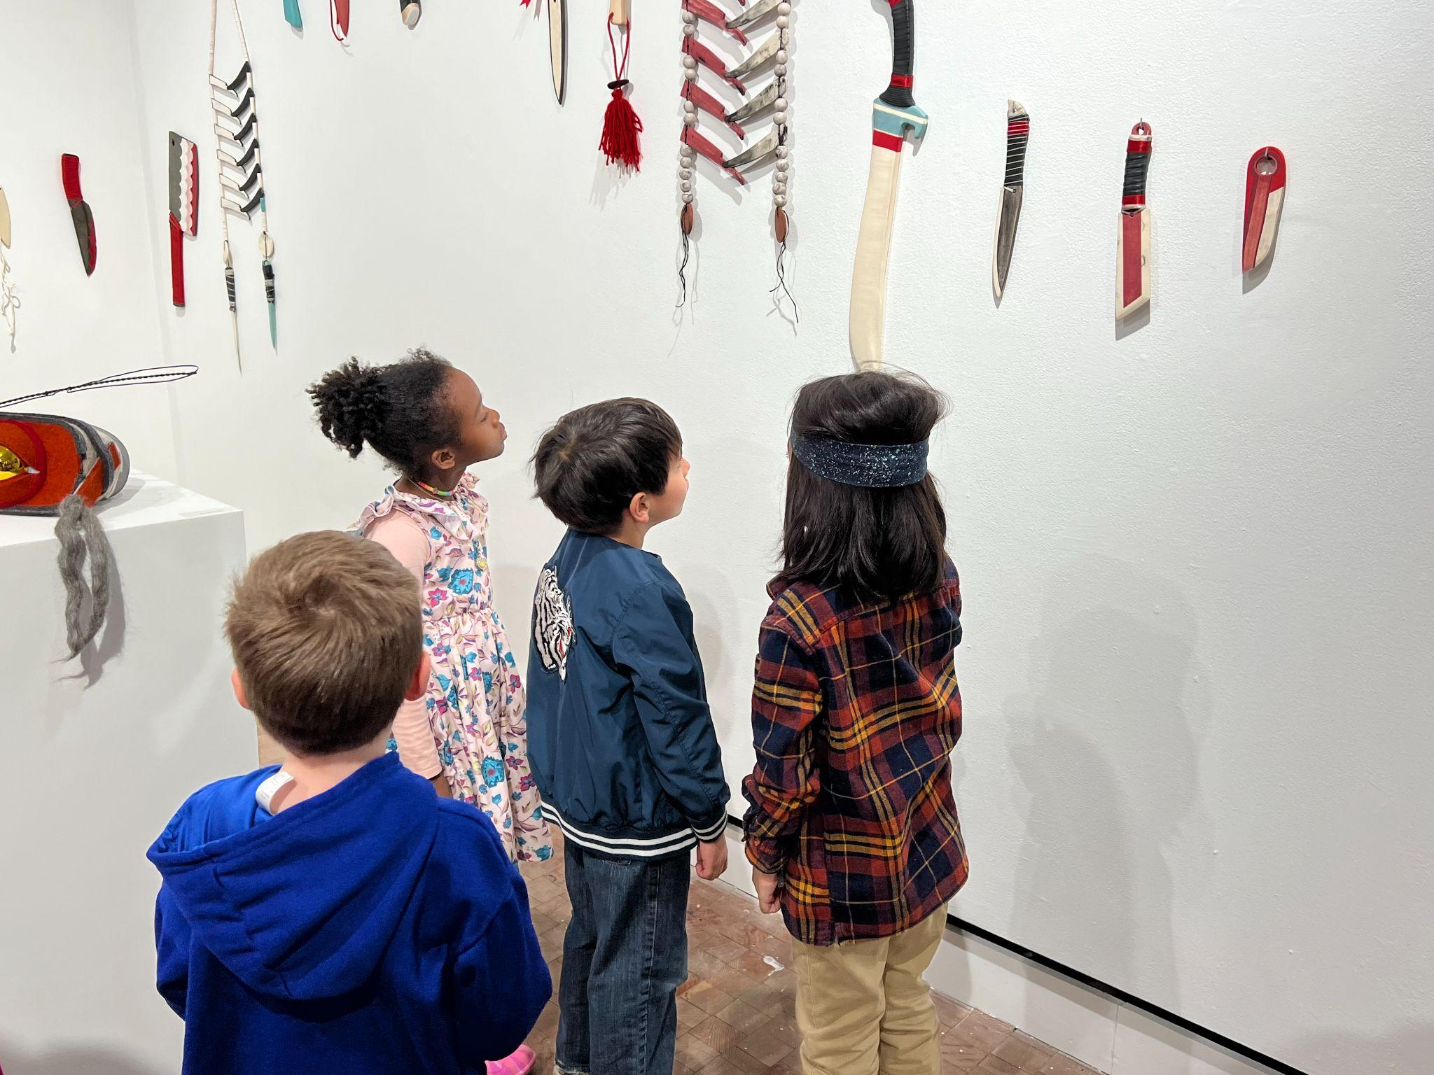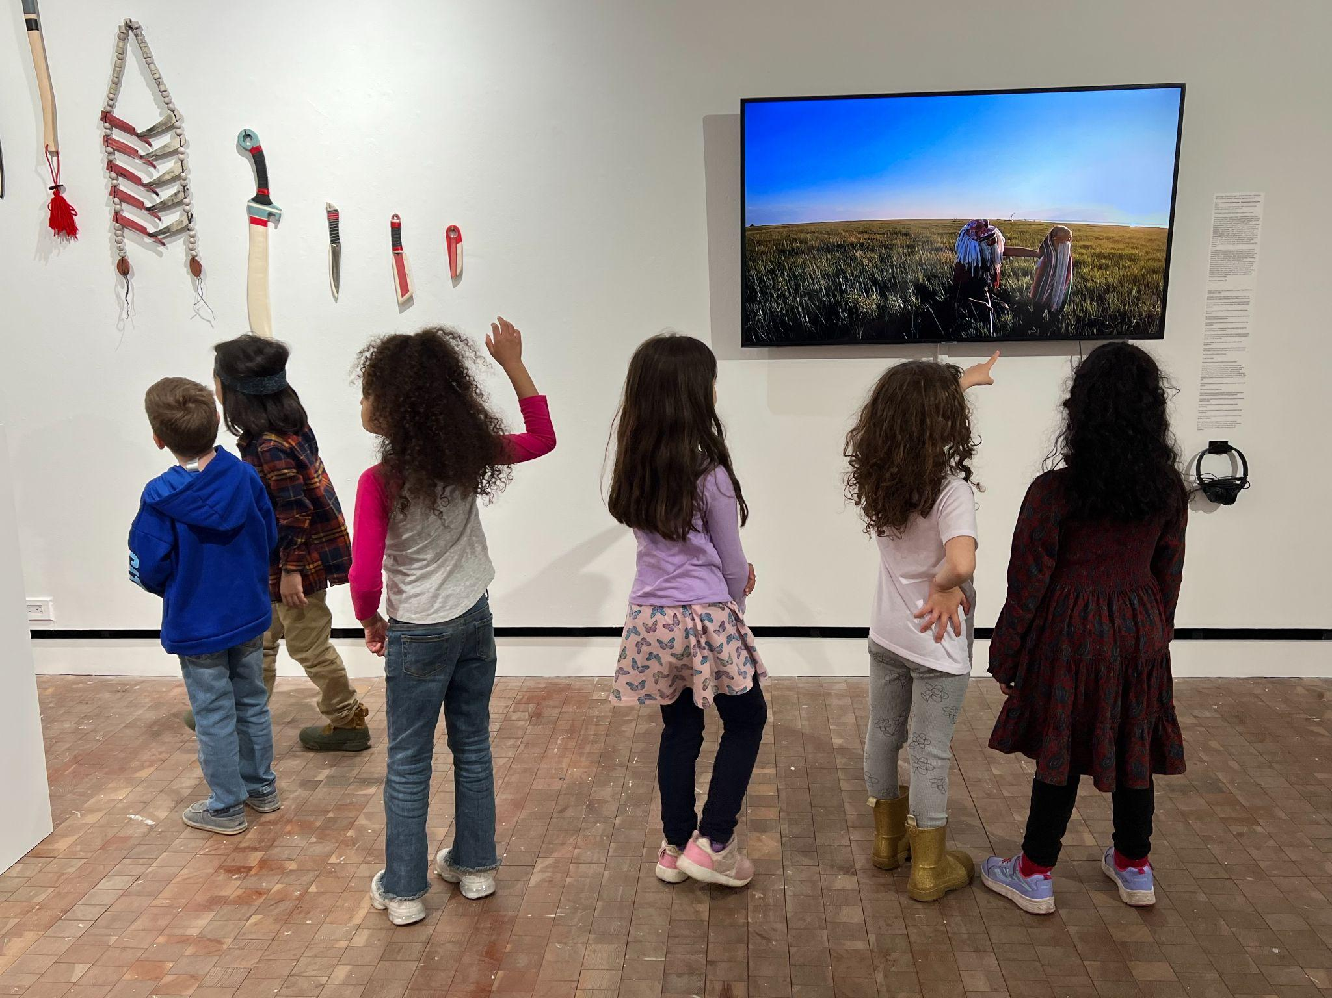
Art-I-Fact and Transmission Fluid 2042, Cannupa Hanska Luger
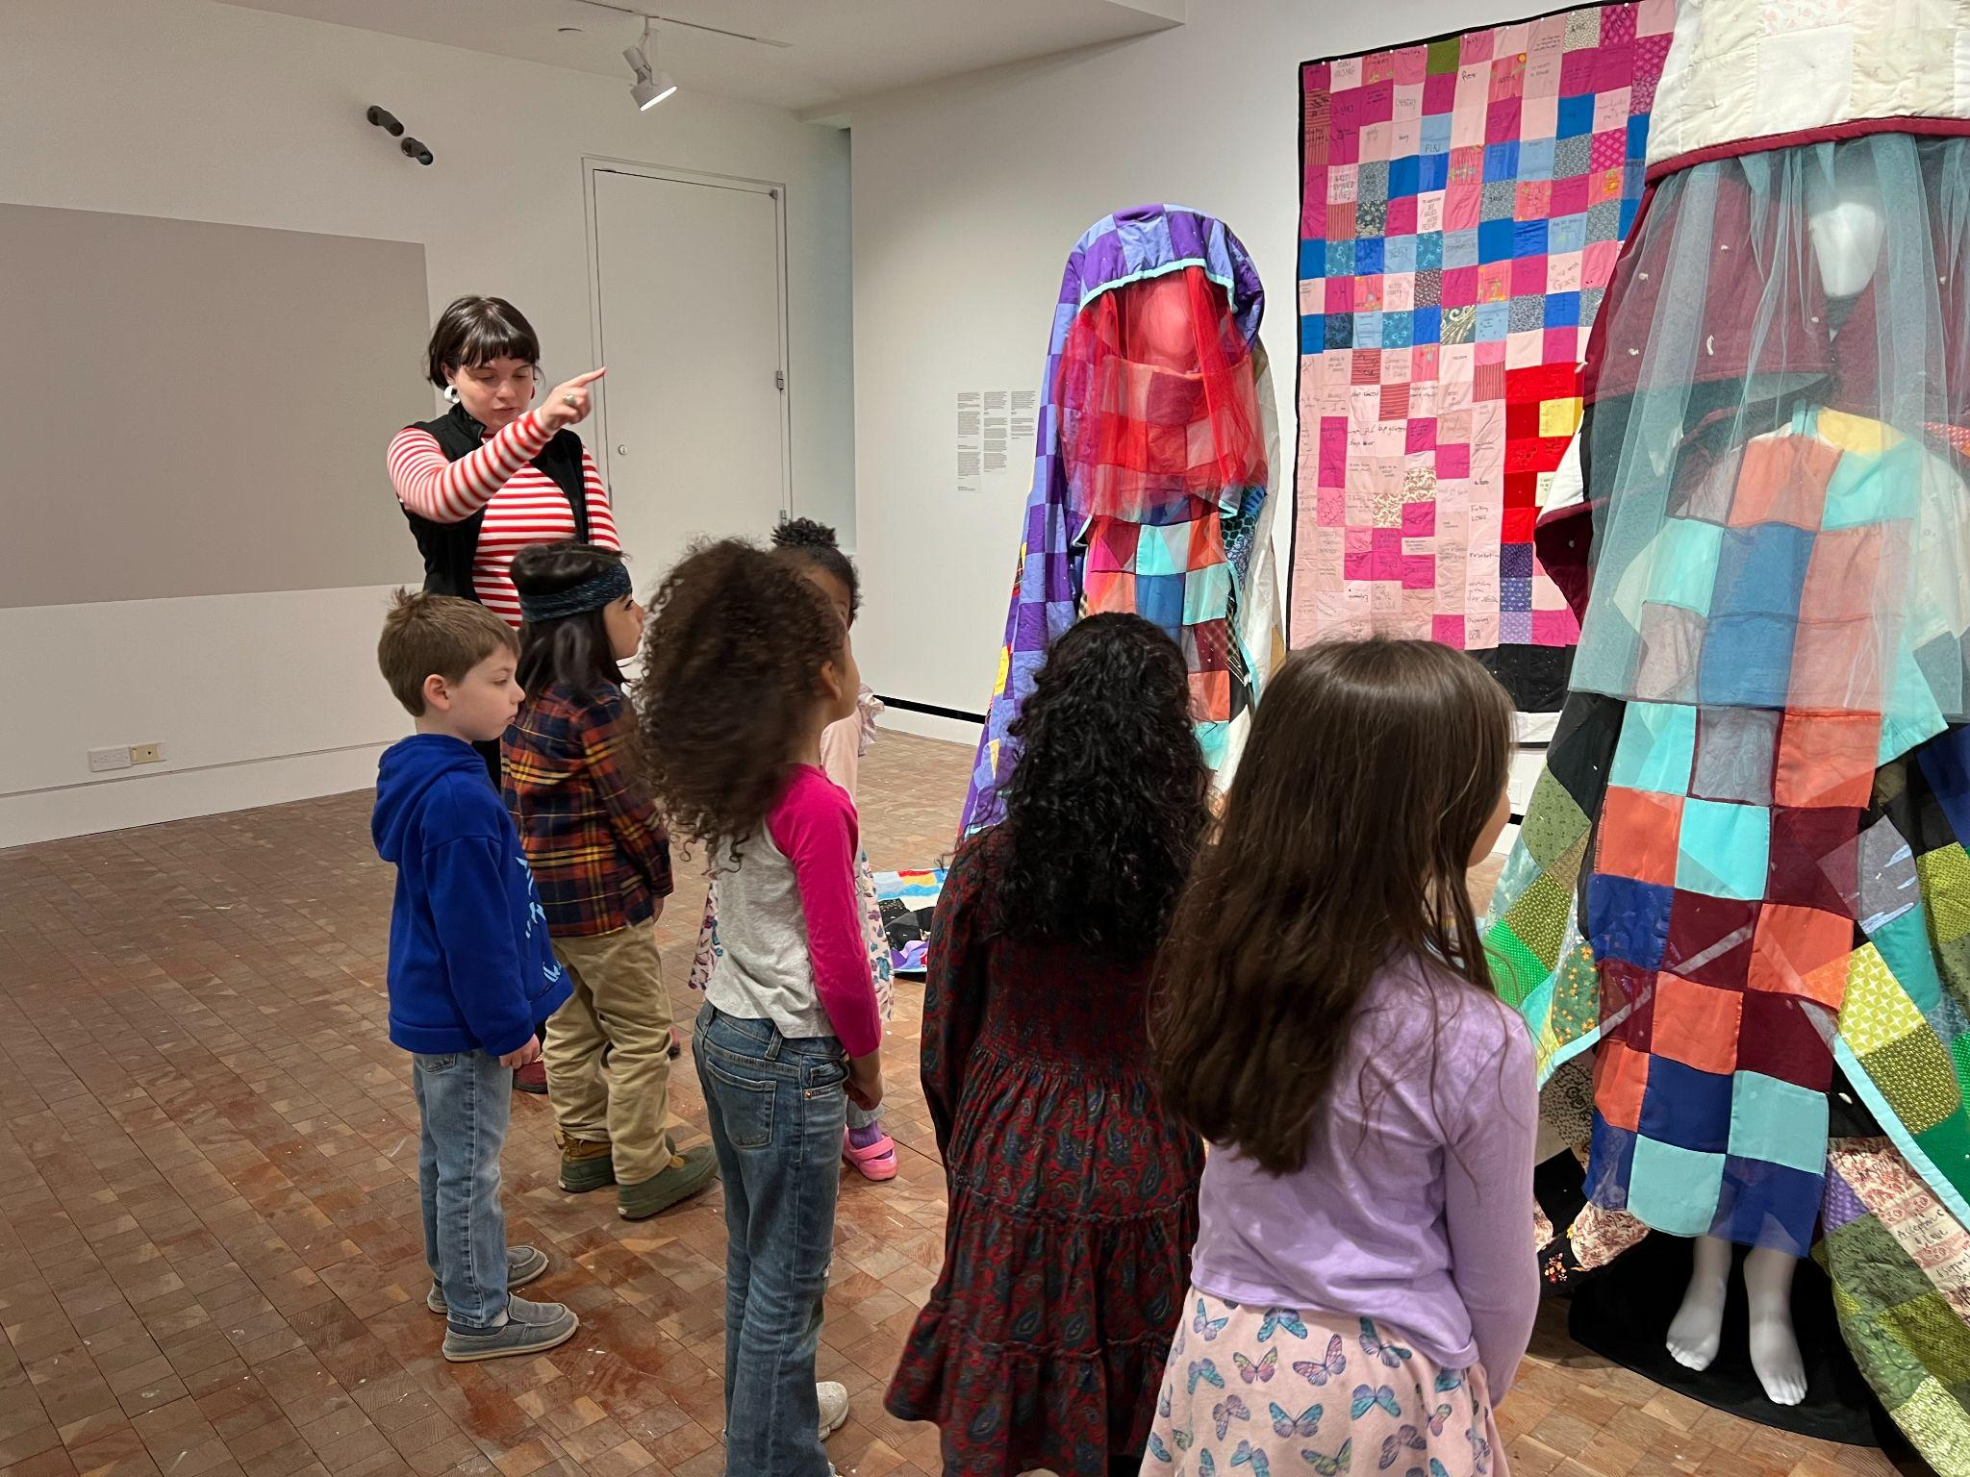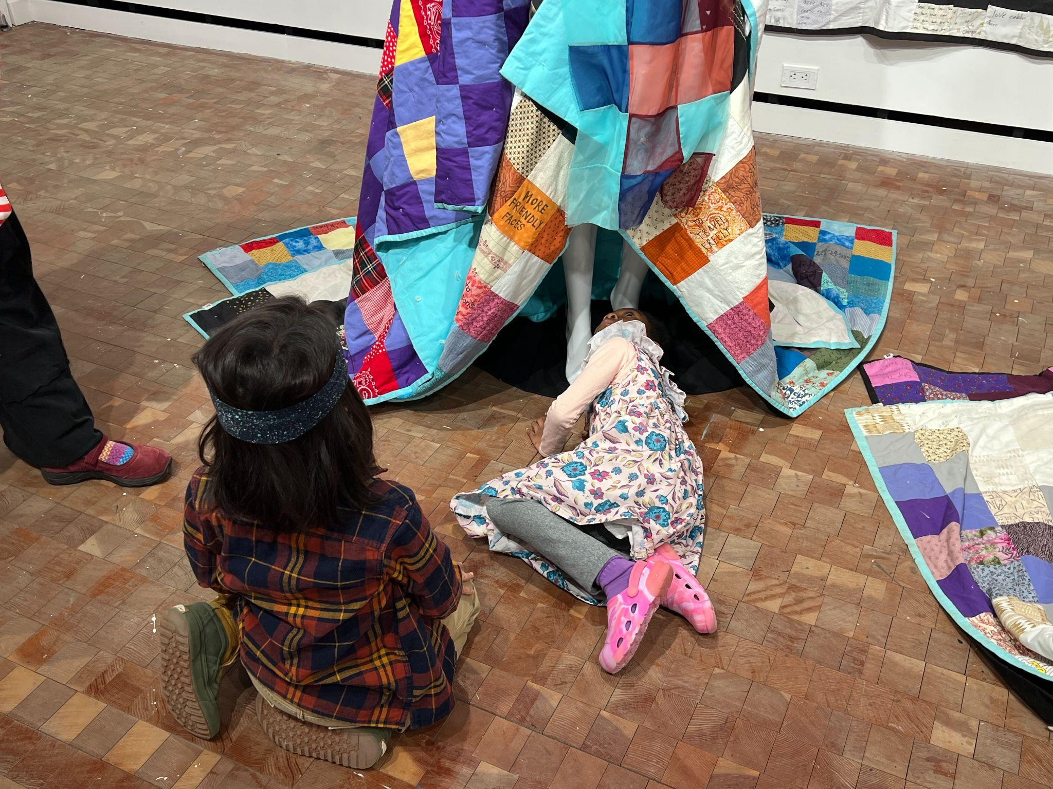
Being Future Being, Emily Johnson
Following the tour, we sat around a table in the lobby to partake in a sewing activity which the ECC students very much enjoyed. I explained how to sew by demonstrating the up and down motions on my own piece of cardboard, and as it turns out a few of them already knew how and could help me guide their other classmates. The students used multicolored string to sew a handmade pattern on squares cut out from old cardboard boxes. The shapes were at first unrecognizable, but they pieced them together in the end to reveal a map.

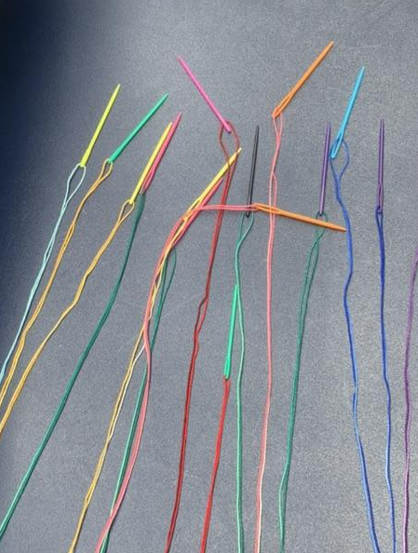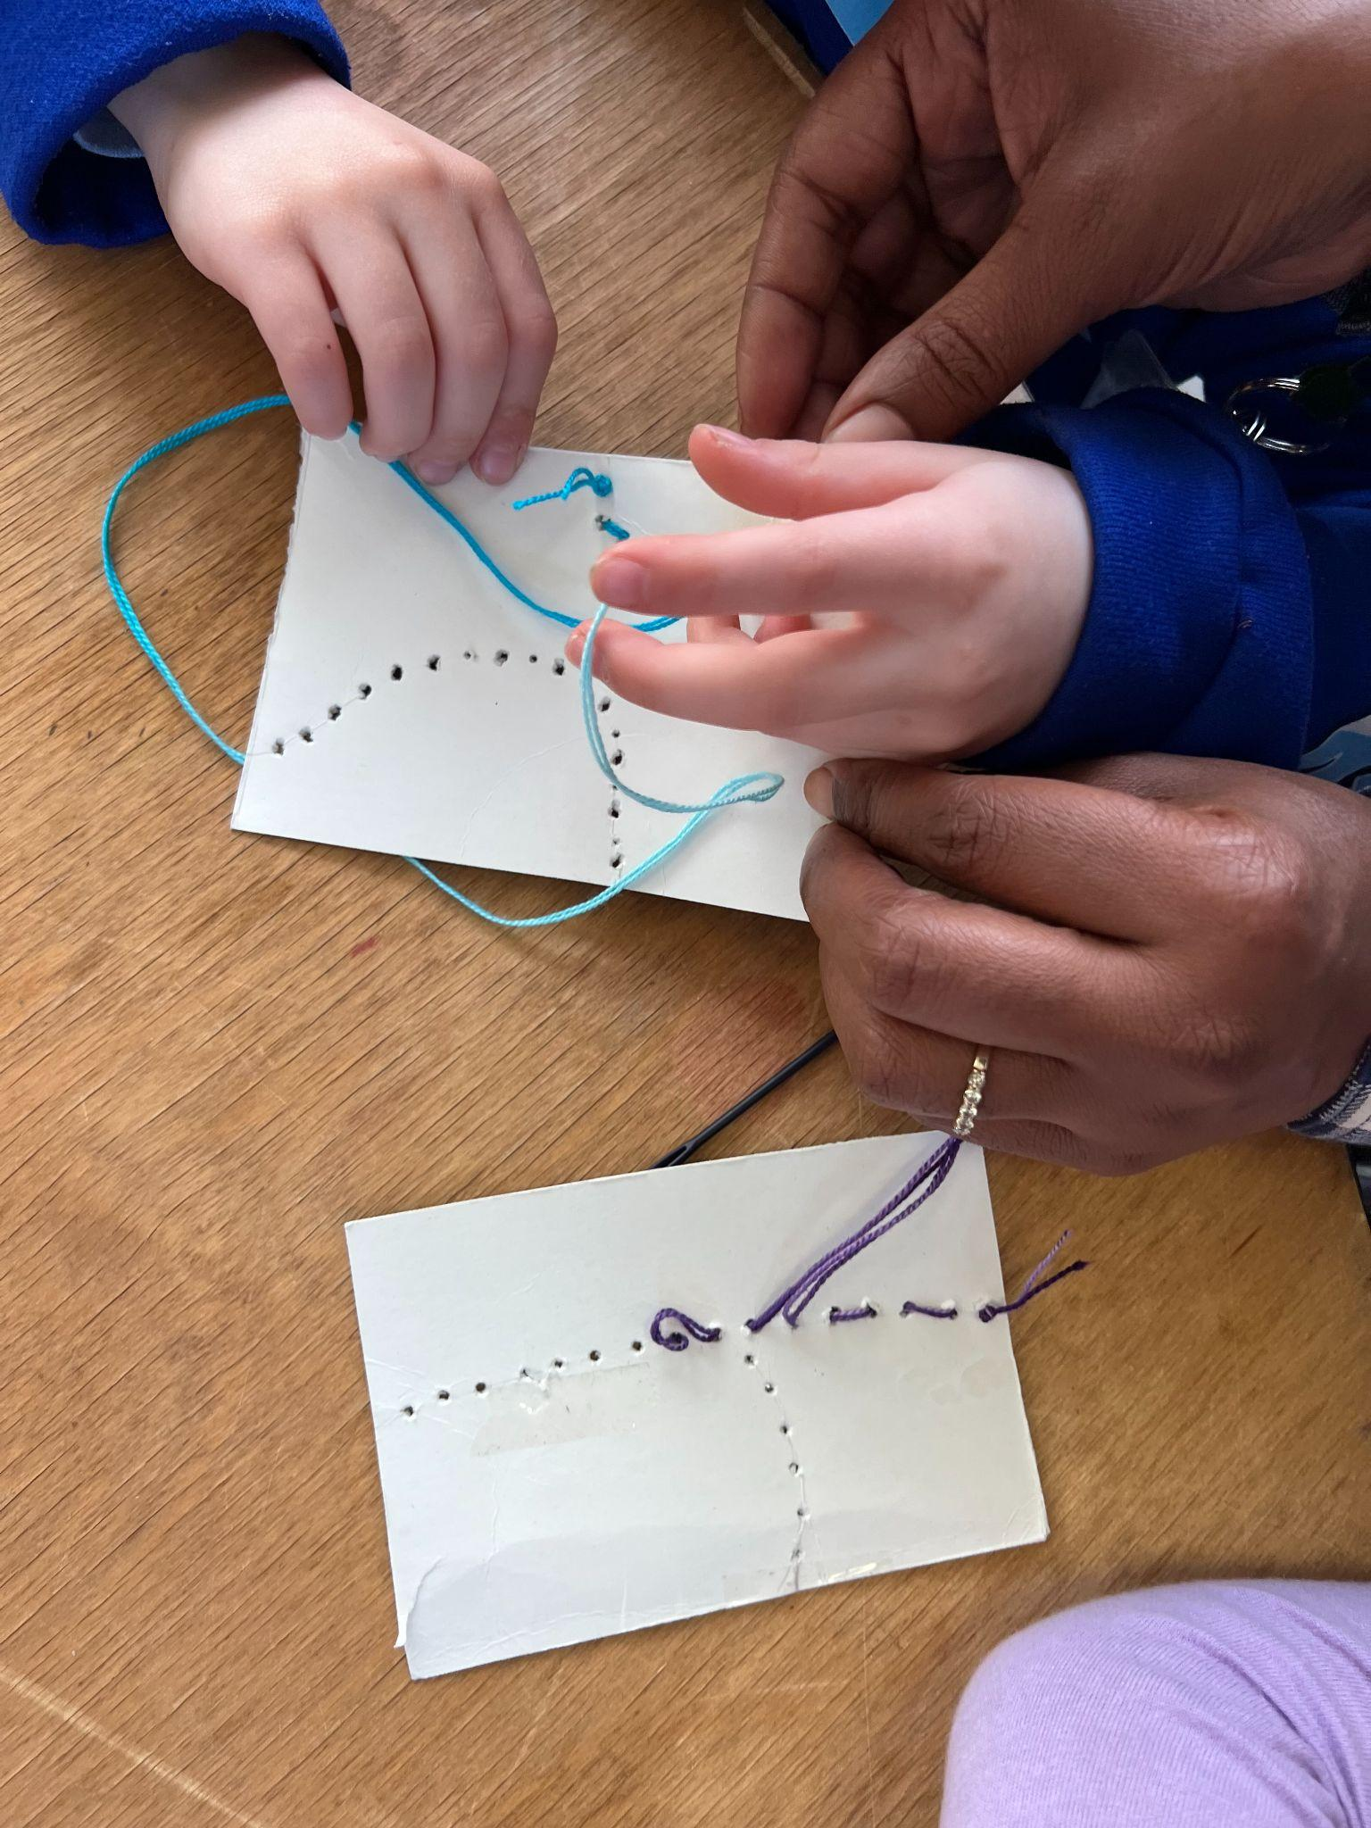
Preparation Process

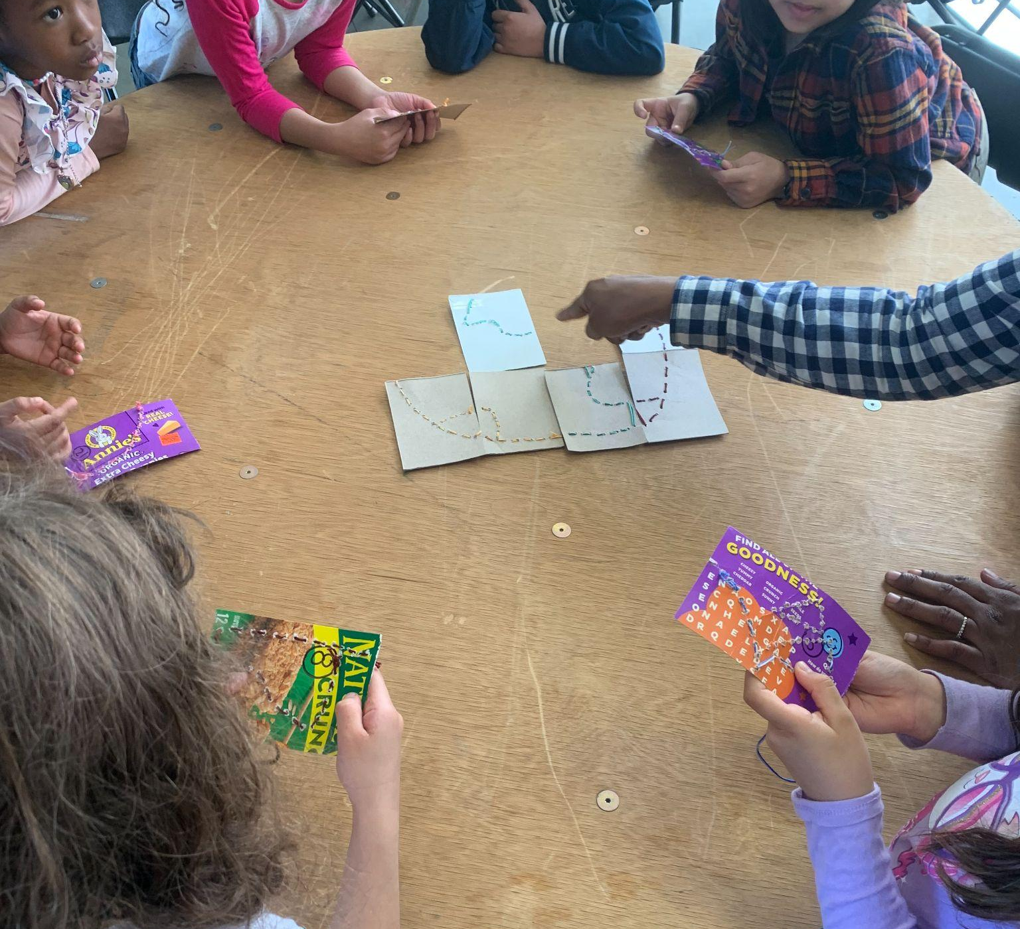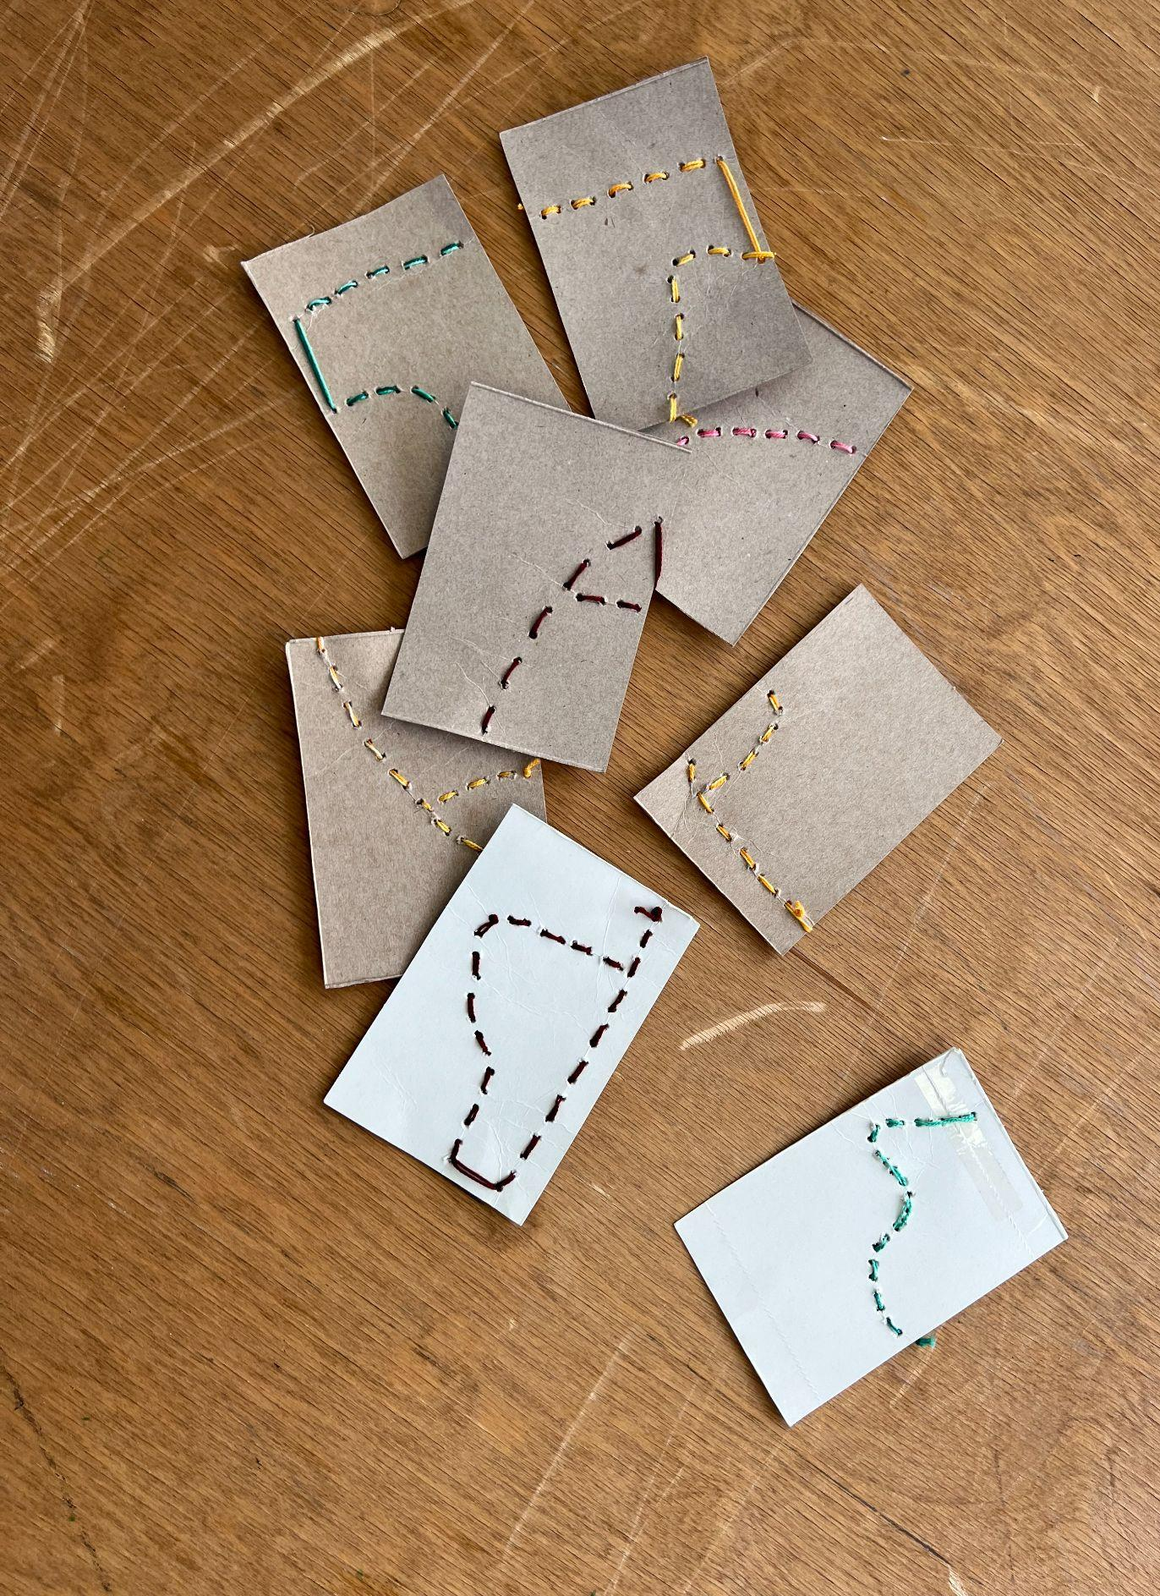
Final

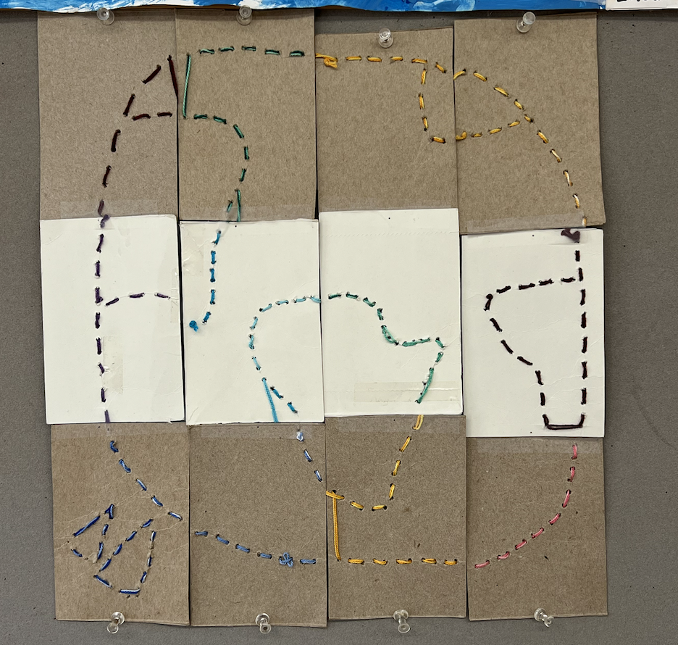
Final, shown hanging in classroom
The map shape allowed us to have place related discussions again, and think about the Above Below Mars-inspired maps. Most significantly though, this activity connected to Emily Johnson's quilts. I explained to the children that they just participated in a piece of community art, like Johnson’s, and they were pleased with this new terminology. Part of Johnson’s process in making her textile pieces was to teach people how to sew, and sew as a community, which we did as well. I encouraged kids to continue to practice sewing and to teach more people (siblings, friends outside of school, etc.) how to sew in the future. I also explained that sewing can be used as a tool, to mend fabric or make clothes. When they pieced the cardboard rectangles together in the end, it was meant to resemble the idea of Johnson piecing quilt squares together, each one with a personal human touch.
Emily Johnson isn’t the only person advocating for and sharing the beauty of collaborative art. I’ve found that scholars and artists alike advocate for this practice. I read part of the book Making Art Together by artists Mark Cooper and Lisa Sjostrom, and they consistently emphasized the importance of collaborative art. They explained that “During the collaborative process, magic happens. Who knew that regular kids, not just select stars, could be taught to work and think like real artists? Who would guess that kids could produce such sophisticated and meaningful pieces of art?”
In addition to the aesthetic bonuses of encouraging kids to work together on art, they went on to explain that collaborative art is a way to help kids feel a part of and feel responsible for community, and for making decisions for the common good. They showed many examples as to how working collaboratively with kids, and connecting their art to the larger world is a valuable process. I think that this map making activity done with the five/sixes is a perfect example of this valuable process.
Finishing off the series of tours with Groundings and with a piece of collaborative art felt so right. So much of my research on museum education and art connected to environment boils down to the importance of community, which is shown in this exhibit not only through the actual sharing of space between artists, but through what they are saying with their art.
As Allison Wikens explains in her journal article “Museums and Community, the Benefits of Working Together”: “Whether redefining their spaces as social forums, exhibiting their collections through community voices, or developing programs for visitor investment, museums have reaped tangible and intangible rewards through community involvement.”
I am happy I was able to share this gallery space with the younger members present on our campus, because all ages are needed in discussions of care, climate justice, and community. All ages have something to offer when it comes to connecting art to larger concepts – including our natural world, and the people we are surrounded by.

Reflecting on Teaching Care and Climate Justice Through on Campus Tours: Art With the ECC Five/Sixes: Project Framework
As the climate crisis becomes an increasingly difficult issue to cope with, I am forced to think about the role I will play in discussing related topics with my future students. Through this project of designing curriculums and giving educational tours to the five and six year old students from the ECC, I was able to investigate ways in which to teach and discuss climate justice and care in engaging, fun, and meaningful ways. We are living through a crucial time in history where almost everyone is thinking through the climate crisis in one way or another. Part of the role of an educator is to think through the most productive ways to discuss these topics with young students, and think through why these conversations are urgent.
The gallery exhibitions presented at Sarah Lawrence this semester, related to Care and Climate Justice, were helpful to guide conversations with students. They were helpful to frame the climate crisis in a way to consider the act of care and thinking about social justice. They were a helpful framework to practice “eco-art” education, which combines science and art in order to deeply engage kids in the workings of our environment.
Additionally, the exhibitions were a way to welcome some of the youngest members on our campus into the larger community, through engaging and educational gallery tours and fun and interactive artistic reflective activities. Museums and galleries have historically been spaces where community building between different ages is made possible, which is so important. Scholar Allison Wickens described in her journal article “Museums and Community” how repeat visits from local school children to museum/gallery spaces can “comfort and increase learning” for all “community members at the museum.”
Hilary Inwood, eco-art researcher and advocator, regularly encourages educators to take their students outside to make art, and to use their “local community as an exhibition site or for inspiration.” She continues to explain in her journal article “Growing Environmentalism through Art Education” that these examples of community engagement and connection can lead to environmentalism, and a want to protect our environment, which is crucial.
Beyond the actual touring and designing of curriculums, I was able to learn about many layers of museum education, and how each layer is extremely important. Museums provide engagement for the youngest members of our society – they “speak directly to a toddler's ability to connect with concrete objects.” They provide framework for teaching issues related to prejudice and multicultural education. And, of course, as we saw through the ECC students in the Sarah Lawrence galleries, they can be spaces that celebrate fun, happiness, and togetherness. They can be spaces to hold discussions of care for our environment, and those most affected by its destruction.
I’m excited to use what I’ve learned about art education and environmental education in the future when I’m a full time teacher. I’ve learned a lot about the concept of “eco-art education” which can be defined as a way to integrate “art education with environmental education as a means of developing awareness of and engagement with concepts such as interdependence, biodiversity, conservation, restoration, and sustainability.” “Eco-art” is an innovative approach to environmental education, going beyond the traditional roots of science by combining it with the creative and sensory approaches of art, in order to make it accessible and fun for students.
All three exhibitions this semester, related to care and climate justice, combined art and science in ways in order to teach and collectively think through these ideas. Our discussions of community and environmental care, our participation in art projects where we had to work together and use previously-loved (used) materials, and our viewing and appreciation of all of the contributed art in these galleries were forms of eco-art education.
Art is a valuable tool when it comes to teaching care and climate justice to young students, and I will remember these lessons moving forward. Art can help us to have uncomfortable conversations, it can help us to imagine positive futures, and it can help to hold us together as we navigate a wounded world. I am reminded of the importance of teaching pressing issues without putting all of the pressure onto the next generation. I am grateful that these exhibitions and these students from the ECC have helped me navigate the ways to have these conversations.

All photos are taken by Delilah Higgins
Tarr, Patricia. “New Visions: Art for Early Childhood.” Art Education, vol. 61, no. 4, July 2008, pg. 21.
Tarr, Patricia. “New Visions: Art for Early Childhood.” Art Education, vol. 61, no. 4, July 2008, pg. 22
Tarr, Patricia. “New Visions: Art for Early Childhood.” Art Education, vol. 61, no. 4, July 2008, pg. 21.
McClure, Marissa, et al. “Defining Quality in Visual Art Education for Young Children: Building on the Position Statement of the Early Childhood Art Educators: Arts Education Policy Review.” Arts Education Policy Review, vol. 118, no. 3, July 2017, pg. 1. EBSCOhost, https://doi.org/10.1080/10632913.2016.1245167
McClure, Marissa, et al. “Defining Quality in Visual Art Education for Young Children: Building on the Position Statement of the Early Childhood Art Educators: Arts Education Policy Review.” Arts Education Policy Review, vol. 118, no. 3, July 2017, pg. 1. EBSCOhost, https://doi.org/10.1080/10632913.2016.1245167
Suina, Joseph H. “Museum Multicultural Education for Young Learners.” The Journal of Museum Education, vol. 15, no. 1, 1990, pg 15.
Wickens, K. Allison. “Museums and Community: The Benefits of Working Together.” The Journal of Museum Education, vol. 37, no. 1, 2012, pg 91
https://www.sarahlawrence.edu/student-life/community-partnerships/civic-engagement/projects/digital-media/multimedia-storytelling.html
https://todayscreativelife.com/easy-stitch-cards/
https://careandclimatejustice.org/exhibition/groundings-care-and-climate-justice/
Photos by Delilah Higgins
Photos by Paola Brasca
Photos by Paola Brasca
Cooper, Mark, and Sjostrom, Lisa. "Chapter 1: Collaborative Art, Making Magic." In Making Art Together, Beacon Press Books, 2006.
Wickens, K. Allison. “Museums and Community: The Benefits of Working Together.” The Journal of Museum Education, vol. 37, no. 1, 2012, pg. 92
https://careandclimatejustice.org/exhibition/groundings-care-and-climate-justice/
Inwood, Hilary. “Shades of Green: Growing Environmentalism through Art Education.” Art Education, vol. 63, no. 6, Nov. 2010, pg. 34.
Wickens, K. Allison. “Museums and Community: The Benefits of Working Together.” The Journal of Museum Education, vol. 37, no. 1, 2012, pp. 91–100.
Inwood, Hilary. “Shades of Green: Growing Environmentalism through Art Education.” Art Education, vol. 63, no. 6, Nov. 2010, pp. 33–38
Erdman, Sarah. “Creating Meaningful Partnerships With Museums.” YC Young Children, vol. 71, no. 1, 2016, pg. 16
Hutton, Kathleen, and Wanda Urbanska. “Examining Prejudice through Art: Reynolda House Museum of American Art.” Art Education, vol. 50, no. 5, Sept. 1997, p. 25.
Suina, Joseph H. “Museum Multicultural Education for Young Learners.” The Journal of Museum Education, vol. 15, no. 1, 1990, pp. 12–15
Inwood, Hilary. “Shades of Green: Growing Environmentalism through Art Education.” Art Education, vol. 63, no. 6, Nov. 2010, pg. 34.

