River Lombardi
Histories of Art & Climate Justice
April 30th, 2024

A FUTURE YOU CAN HOLD IN BOTH HANDS: A Visual and Contextual Analysis of Cannupa Hanska Luger’s Art-i-Fact

INTRODUCTION “THESE ARE TRAPPED TOOLS FOR OUR CURRENT BATTLE”
“In order to become visible as Native subjects, not merely as degraded or romanticized stereotypes, Native artists, writers, and activists continue to challenge historical misrepresentations. Like many marginalized groups, they must intervene in a long history of textual and visual domination to simultaneously revise historical representations and generate more accurate and dynamic ones” America’s colonial past and present create a seemingly impenetrable barrier between Indigenous peoples and the truths of their existence. Cannupa Hanksa Luger is one of many Native American artists seeking to take agency over his own narrative. Born in 1979 on North Dakota’s Standing Rock Sioux Reservation and currently located in New Mexico, Luger focuses on the concept of Indigenous futurity, the assertion that Indigenous populations are not dying out or trapped in the past. Art-i-Fact (2020), is a sculptural expression of Indigenous futurity that works against a major American institution: the museum. Luger addresses timeless oppression of native populations and critiques the institutional role of museums in displaying cultural artifacts as evidence of the “dead Indian”. This artwork specifically addresses native objects and tools that are displayed as relics of the past and most often stolen for these displays without the knowledge and/or permission of the culture from which they belong to. Art-i-Fact takes tools fabricated by Luger himself and displays them as if they were in a historical exhibition. The tangibility of these objects brings into question the role of museums in distancing contemporary audiences from Indigenous culture and contributing to the continued displacement and violence experienced by countless tribes in America.

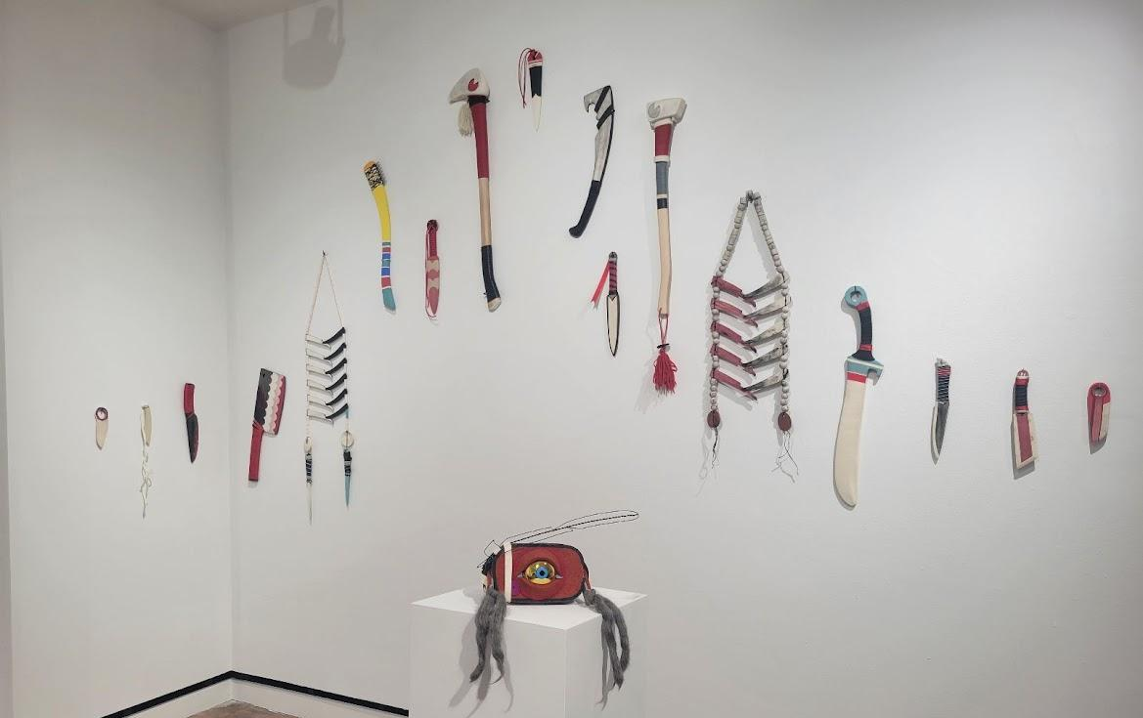
Cannupa Hanska Luger, Art-I-Fact, 2020, Sarah Lawrence College Gallery Exhibition “Groundings: Care and Climate Justice,” 2024

“INSTRUCTIONS FOR USE ARE EMBEDDED IN OUR GENETIC MEMORY”
Art-i-Fact takes the form of ceramic objects created by Luger himself, all examples of Indigenous tools, jewelry and technology which are hung on the wall in a similar fashion to the typical museum display. This arrangement is accompanied by text containing definitions of the word “artifact” as “an object made by a human being, typically an item of cultural or historical interest” or “something observed in a scientific investigation or experiment that is not naturally present but occurs as a result of the preparative or investigative procedure.” These definitions suit a general understanding of what artifacts are and how they are acquired. There is an assumption of ethnographic display that strays from artistic view, placing cultural objects in a rigid context outside of their artistry. We see these objects as specimens to be examined or investigated. Historically, these displays have been curated by the same explorers who uncovered the featured objects. Indigenous items are often associated with primitiveness, refusing to acknowledge the skill, patience and knowledge that goes into their creation. Museum displays serve to separate the viewer from the reality of what these artifacts mean. We see these collections for their value, especially when placed in the context of a larger archive belonging to a historical institution. European settlers collected cultural artifacts like trophies, showing off their “discoveries” as achievements of humanity and the God given right to conquer. The value of individual objects changes as the meaning we give to them changes. Factors like rarity and material may influence how we put a monetary price on an object and influence our view of cultural collections as symbols of wealth and status. By limiting the preservation of culture to the rich and powerful, we isolate a real community of people from their own culture. Indigenous knowledge is passed down through generations and as Native American populations are continuously targeted by hate crimes and systemic violence, there rises a strain on the preservation of traditions and cultural knowledge. Without living accounts of traditions and skills, a culture begins to die with its people. Luger’s Art-i-Fact works to combat this erasure of culture by drawing attention to Indigenous intelligence and how objects influence our view of cultures different from our own.

“THESE ARE NOT ANCIENT ARTIFACTS”
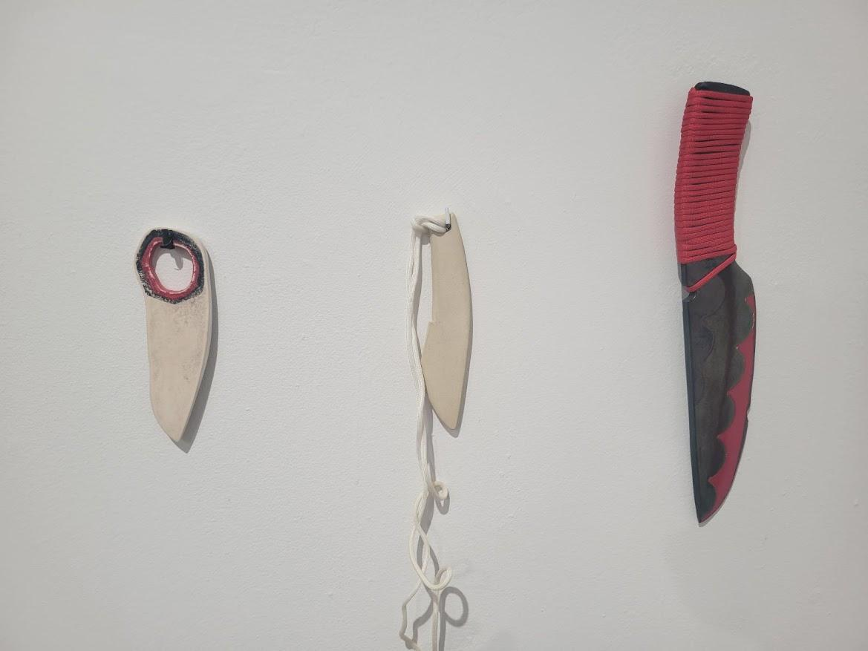
Art-i-Fact features prominently the colors, red, white and black. Red stands out to me as a color that often represents anger or violence, even associated with blood. There is also a tie between red and Indigenous people, including the derogatory term “redskin,” and the use of red face paint in fictional depictions of Indigenous people to represent their “cruelty” and “savagery.” The display of Art-i-Fact in UOregon’s Museum of Natural and Cultural History features a red backdrop as well. While red is often associated with violence, it is also a bright, vibrant color that draws the viewer’s attention. Using red makes the sculptures more prominent, especially against the white backdrop used in the gallery at Sarah Lawrence College. It also brings to attention the assumptions we have about Native American culture and the way we expect these objects to be used. Knives are objects associated with violence and injury, but they can also be used for constructing other tools and objects, as well as preparing food. The assertion of these objects as tools is also based on the assumption that they are not art, but must be categorized otherwise. White is another prominent color in this piece, in this case a rather bright white. Luger emphasizes the contemporary nature of these pieces by using this clean, bright, pristine color. There is no dirt or wear on these pieces, they are very clearly untouched works of art that have not been used. Utilizing the cleanliness of the color white with the vibrant color red, as well as smaller portions of blue and yellow creates a sense of newness, bringing forth the attention to detail exemplified in Luger’s work and the time in which this work was created.

“THESE FIT IN OUR HANDS. THESE REST ON OUR SHOULDERS.”
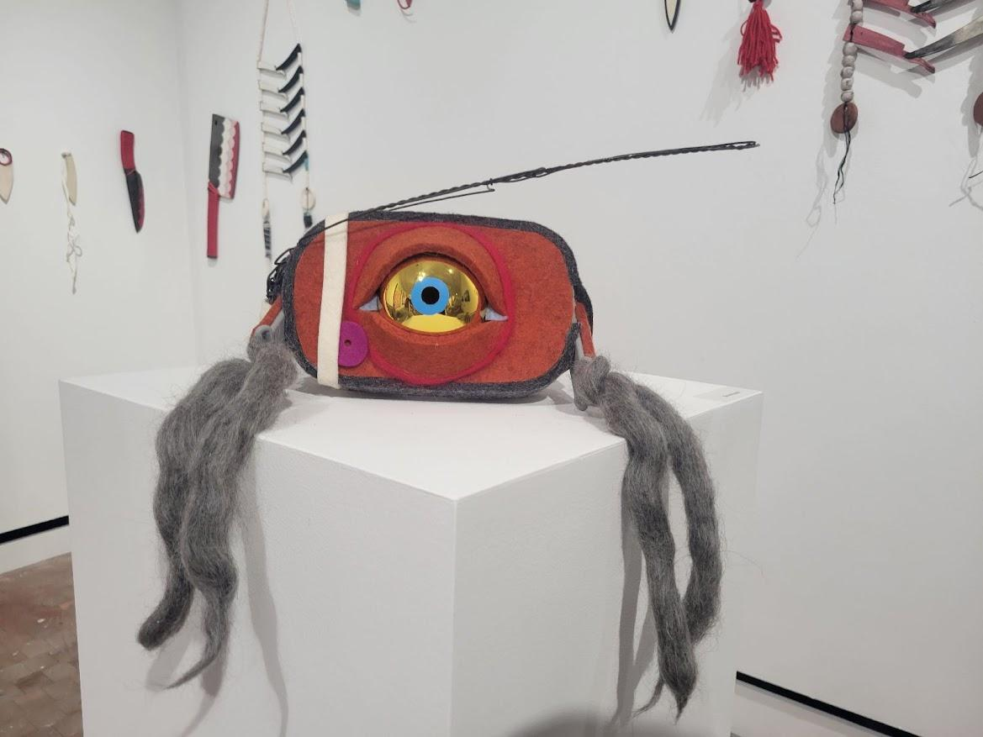
Artist Fred Wilson explains that objects are imbued with memory. By investigating the time, material, purpose and location of an object we begin to make associations and connections back to ourselves. Art-i-Fact is a very tactile piece. Material is especially important, as Luger created each tool himself out of ceramic. Ceramic is fragile while still being heavy and dense in texture. This material is often associated with fine art and more sophisticated objects that serve mainly for decoration. Luger brings these pieces into modernity by using this material, especially considering the abundance of ceramic objects mass produced for sale in American stores. You can find decorative objects made of ceramic material for sale in many places. The ease of access provided by modern department stores is removed when tools are created by their user; they require much more time and resources that one must face directly as they construct an object. The viewer is faced with the delicacy of these objects. Despite the work that went into the creation of a sculpture, it can still be broken if handled improperly. The use of ceramic material emphasizes the endurance of Indigenous culture, but also the fragility of our perception and how easily we lose access to knowledge when we “handle” it improperly.
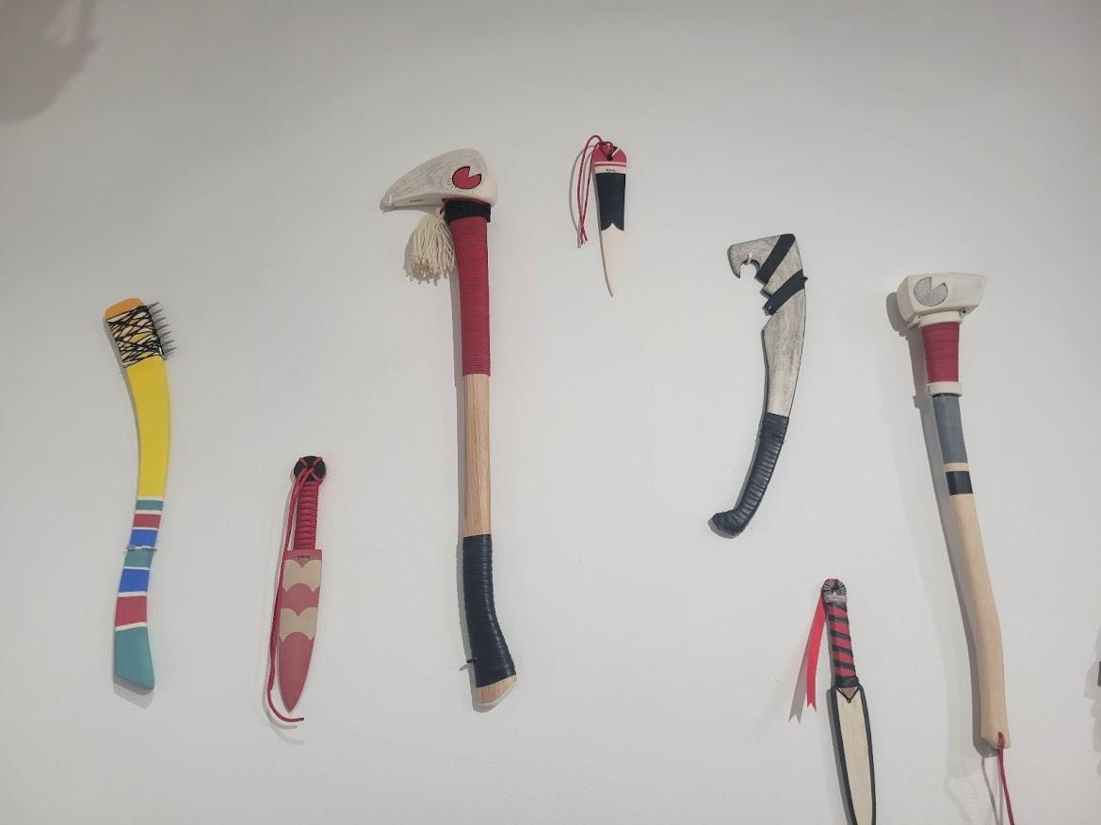
The items included in this sculpture also have different functions. Some are weapons such as blades, axes and arrows, but there are also jewelry and masks. The virtual reality headset is especially interesting and stands out as the most modern technology on display. Luger uses modern technology such as ceramic clay and this VR headset to bring our idea of indigenous culture to the present day. The tactility of these objects makes them even more real. Using tangible pieces that beg to be handled, we find ourselves frustrated that the art is not easily accessible, the same way Indigenous people may experience anger or frustration about their cultural artifacts being stolen from them. When displayed without the glass case, we are close enough to touch each sculpture. The reality of these tools is emphasized by the ease in which we can imagine ourselves holding them. You can even kneel slightly and place yourself at eye-level with the VR headset and look through it. If you were to handle these pieces, they have weight and texture that connects you and your senses directly to the object, but you are not allowed to. There exists a human fascination with viewing another culture, especially through objects, that Luger is playing with. Physical items serve as perceptible evidence of a culture’s existence. Fred Wilson highlights the hypocrisy of museum displays, saying that “although indigenous objects often serve as essential forms of material evidence and the physical presence of indigenous groups, absent are the contradictions under which such objects come to define indigenous culture”. The first discoveries of Native American objects were not by historians but paleontologists. In their efforts to uncover fossils, these scientists also dug up Indigenous tools and jewelry. Initially, a connection was made between these cultural items and the primitive time period of cavemen and dinosaurs, but as studies progressed there arose proof that Native American culture was, in fact, keeping up with the times. However, the initial connection to a less developed civilization was utilized to argue against the humanity of Indigenous peoples and culture. Luger’s choice to use physical, tangible items in his sculpture utilizes preconceived notions of artifactual objects to bring into question the common practices that created harmful perceptions of Indigenous peoples. Brenda Trofanenko speaks on the way that items create a sense of accessibility in the viewer. “The materiality and physical presence of objects within a museum provide the public with perceived access to understanding the indigenous world and, more specifically, indigenous culture”. There is an illusion of truth provided by our trust in museums as an institution, and we often take the information provided by a museum as fact without question. We associate our access to cultural artifacts with access to the culture itself, regardless of the real distance between the two. Luger’s sculptures evoke this sense of connection with culture, then ask the viewer to investigate this feeling further. The fabrication of the objects themselves can be connected to the fabrication of closeness between the viewer and a culture which is on display.

“THESE WERE NOT STOLEN FROM BURIAL GROUNDS”
Luger’s arrangement of the sculptural pieces in Art-i-Fact assists in the critique of modern ethnographic displays. In the UOregon exhibition specifically, Luger utilizes aspects of typical museum exhibits such as the glass case, plaques of information, graphic titles and arrangement of the items on the wall. At first glance, you may not notice the difference between this work and the expected layout of a museum display. There are even a few photographs included in the exhibit, creating an informative appearance.
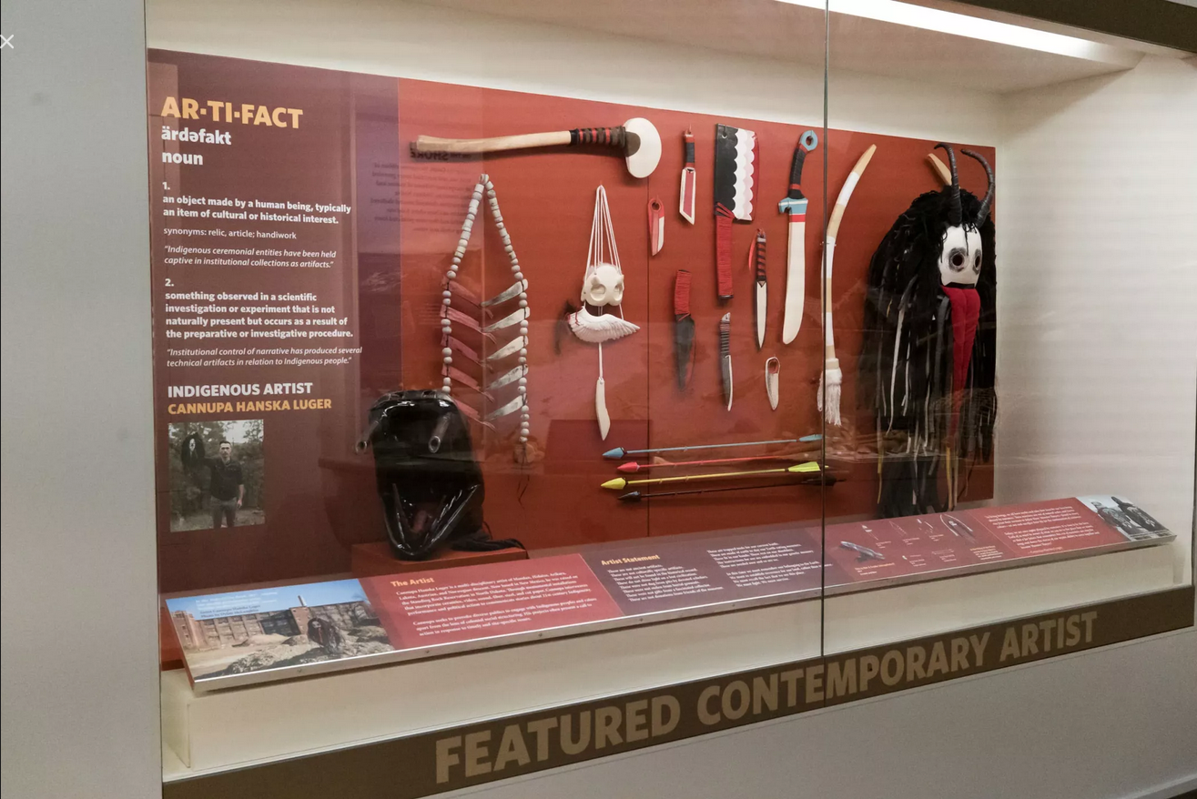
Cannupa Hanska Luger, Art-I-Fact, 2020 (Museum of Natural and Cultural History: UOregon)
The white backdrop in SLC’s exhibition is rather different. As stated before, the tools are within reach, not hidden behind glass, and the VR headset is on a pedestal, able to be viewed from 360 degrees. This method of display allows for more interaction with the piece. You can also connect yourself to them directly. Even if you can’t place your hands on the sculptures, you can get close, maybe even breathe on them. This is different from the “look don’t touch” culture of historical museums. This does, however, imitate more artistic displays of objects and sculptures, emphasizing the time and talent that goes into the creation of artworks such as these.
Luger’s use of the text on his wall label also assists in the subversion of expectations. Emphasized by the work of fellow artist Fred Wilson, there is meaning in what both is and isn’t on display. Both Luger and Wilson create artwork that forces the audience to question their assumptions and understand the influence of museum display techniques. While Wilson‘s work alters pre existing exhibits, Luger’s Art-i-Fact instead imitates them to evoke familiarity and create personal connection to subjects that are often made to be impersonal. Luger’s definitions of artifact are accompanied by a poetic arrangement of statements that point to assumptions and contradictions of ethnographic displays. We not only gain context from this text but also a personal feeling of grief, frustration and resilience.
“These
will not be found in the historical record.
These
do not shine light on a lost civilization.
These
were not dug from pits by devoted scholars…
These
were not gifts from a fascinated collector.
These
are not donations from friends of the museum.”

Luger organizes the text in a way that emphasizes the word “these,” consistently pointing back to the objects on display. Luger specifically addresses the source of these sculptures, giving examples of typical methods in which museums acquire artifacts of interest. He intentionally removes this work from the perceived context, emphasizing that this display is NOT the same as one you would find in a museum exhibit, despite the similarities.
Luger also utilizes the expectations of how art is to be experienced in a curatorial context. Museums create an experience that focuses on the use of one particular sense, specifically sight. Although some works may utilize sound as well, the emphasis is placed on displaying exhibits in a visually engaging and informative way. Wilson talks about the expectation for behavior that comes along with space. There is an assumed level of knowledge associated with museum-goers, and this influences what information an exhibit may or may not provide. As Wilson says, museum officials “don’t have to completely understand every kind of person, culture or community. They just have to understand that there will be gaps in their personal knowledge about people that they probably don’t even know that they have. They need to leave their assumptions at the door and learn from visitors and non-visitors alike”. Operating outside of an intellectual lens is helpful, as it overrides assumptions about common knowledge and encourages the provision of accurate, in-depth information. Luger gives himself agency in choosing the arrangement of his own artwork, a privilege not given to the creators of artifacts that are uncovered and displayed by complete strangers. Wilson highlights the ways that museum officials manipulate perception in the design of their displays, something that Luger is able to do for his own work. Both of these artists shine a light on a key aspect of museum practice, that “the process of making, appreciating, and exhibiting art, particularly in the kind of institutions we call museums, is itself an intensely political process…[This process is] understood and appreciated in terms of accumulated knowledge and received wisdom about what museums are, and what exhibits are, and what exhibits mean”. Preconceived notions of what is worthy of display are rooted in cultural trends and politics of the time. In February of 2024 museums began to close displays of American Indigenous culture. Starting with the Field Museum in Chicago, exhibits were covered or taken down to reflect the requests of Indigenous protestors and activists. These institutions were responding to political actions by choosing to withdraw their displays, proving that outside influences do affect the way we perceive history and culture. Even works like Art-i-Fact are influenced by institutions such as the museums that create our expectations for displaying art or cultural objects. Luger’s use of subversion could not exist without the establishment of what is considered “normal”. The artists’ direct influence on his own work is in direct counter to the lack of indigenous presence in the majority of Native American cultural displays. The activists that pushed for the removal of Indigenous exhibits brought to attention the 1990 Native American Graves Protection and Repatriation Act (NAGPRA), passed by George H. W. Bush, which contains regulations that require institutions to obtain consent from affiliated indigenous nations before putting their cultural objects on display. Legislation such as this is essential to bridging the gap between Indigenous people and museum curators. Shannon O’Loughlin, head of the Association on American Indian Affairs says that “when institutions actually have a conversation with affiliated Nations, they finally learn what they have in their collections”. Luger is a prime example of the importance of agency in cultural display. A viewer gains knowledge from the display of Art-i-Fact because of the subversion of expectations.

CONCLUSION: “WE MUST FIGHT. WE MUST SURVIVE”
Artists such as Cannupa Hanksa Luger are doing essential work to create displays of Indigenous futurity. Art-i-Fact is a work that utilizes irony, taking our assumptions about culture and knowledge and using them to prove why those assumptions are, in fact, wrong. Luger brings into question the institution of a museum, asking the viewer to connect their present self to objects that are usually assumed to be relics of the past. He plays with tactility, creating objects that are tangible as useful tools but ultimately unable to be touched or utilized for their assumed purpose. Encasing these artifacts in a glass case further separates the audience from what is familiar but ultimately foreign to them, as a multitude of forces come together to remove genuine Indigenous presence from modern culture. Luger not only critiques museums, but also actively works against the oppression they impose upon him. The artist takes control of his own story, molding pieces of art to display the resilience of peoples who have faced incredible violence to demand a future that is filled with Indigenous knowledge and culture. The division of the word “artifact” into Art-i-Fact not only emphasizes both artistry and information, but also isolates the first person pronoun, I. Between the intersection of art and fact is “I”, representing Luger himself, but also the community of Indigenous voices that have been and continue to be silenced.

WORKS CITED
Adam Schrader ShareShare This. “Indigenous Groups Respond After U.S. MuseumsCover Native Artifacts.” Artnet News, 2 Feb. 2024

“Artists.” Forge Project, Forge Project, 2024
Brenda Trofanenko. “Displayed Objects, Indigenous Identities, and Public Pedagogy.” Anthropology & Education Quarterly, vol. 37, no. 4, 2006, pp. 309–27. JSTOR

Browarny, Laura, "Art, Artifact, Anthropology: The Display and Interpretation of Native American Material Culture in North American Museums" (2010). Seton Hall University Dissertations and Theses (ETDs). 736.
“Cannupa Hanska Luger in ‘Friends & Strangers.’” Art21, Art 21 Inc., 20 Oct. 2023

Henry, Rosita, et al. “Ethnographic Artifacts and Value Transformations.” HAU: Journal of Ethnographic Theory, vol. 3, no. 2, June 2013, pp. 33–51

Hertha D. Sweet Wong, "Hachivi Edgar Heap of Birds’s Artwork: “Native Peoples Have Chosen Art as Their Cultural Tool and Weapon,” in Picturing Identity: Contemporary American Autobiography in Image and Text (Chapel Hill: University of North Carolina Press, 2018), 214-28.

Karp, Ivan. “Constructing the Spectacle of Culture in Museums.” Thinking About Exhibitions, 1st ed, Routledge, 1996, p. 12.

Kathya Lopez, “Decolonization and Fred Wilson’s ‘Mining the Museum.’” Global Museum SFSU, 4 Jan. 2019

Mark A. Graham. “An Interview with Artist Fred Wilson.” The Journal of Museum Education, vol. 32, no. 3, 2007, pp. 211–19. JSTOR

Rooksberry, Jacqueline. “Traditional Art or Ethnographic Objects – Decolonizing Me!” Museum Studies at IUPUI, 6 Dec. 2017

Hertha D. Sweet Wong, "Hachivi Edgar Heap of Birds’s Artwork: “Native Peoples Have Chosen Art as Their Cultural Tool and Weapon,” in Picturing Identity: Contemporary American Autobiography in Image and Text (Chapel Hill: University of North Carolina Press, 2018), 217
Henry, Rosita, et al. “Ethnographic Artifacts and Value Transformations.” HAU: Journal of Ethnographic Theory, vol. 3, no. 2, June 2013
Rooksberry, Jacqueline. “Traditional Art or Ethnographic Objects – Decolonizing Me!” Museum Studies at IUPUI, 6 Dec. 2017
Henry, Rosita, et al. “Ethnographic Artifacts and Value Transformations.”
Mark A. Graham. “An Interview with Artist Fred Wilson.” The Journal of Museum Education, vol. 32, no. 3, 2007, pp. 211–19. JSTOR
Rooksberry, Jacqueline. “Traditional Art or Ethnographic Objects – Decolonizing Me!” Museum Studies at IUPUI, 6 Dec. 2017
Brenda Trofanenko. “Displayed Objects, Indigenous Identities, and Public Pedagogy.” Anthropology & Education Quarterly, vol. 37, no. 4, 2006, pp. 309–27. JSTOR
Henry, Rosita, et al. “Ethnographic Artifacts and Value Transformations.” HAU: Journal of Ethnographic Theory, vol. 3, no. 2, June 2013
Brenda Trofanenko. “Displayed Objects, Indigenous Identities, and Public Pedagogy.” Anthropology & Education Quarterly, vol. 37, no. 4, 2006, 309
Kathya Lopez, “Decolonization and Fred Wilson’s ‘Mining the Museum.’” Global Museum SFSU, 4 Jan. 2019
Mark A. Graham. “An Interview with Artist Fred Wilson.” The Journal of Museum Education, 2007, 213
Karp, Ivan. “Constructing the Spectacle of Culture in Museums.” Thinking About Exhibitions, 1st ed, Routledge, 1996, 185
Adam Schrader ShareShare This. “Indigenous Groups Respond After U.S. Museums Cover Native Artifacts.” Artnet News, 2 Feb. 2024
Adam Schrader, ShareShare This. “Indigenous Groups Respond After U.S. Museums Cover Native Artifacts.”
Adam Schrader, ShareShare This

